Testing Procedures
for AWARE
Determining Your Caseload Number

To the Tester: This is a walkthrough on how to determine what your Caseload Number is. The steps will also show you how to set that caseload number as your default caseload search.

1. Login to Aware
2. Search for Caseload Number
3. Update Preferences

Activity Name | Testing Procedure Notes
Objective 1: Login to Aware
1.01 Enter Username | - For UAT Environment using a Chrome browser, navigate to: https://test.ny.hostedaware.com/Awareuat and enter your Username.
1.02 Enter Password | - Enter your password and click the Log In button.
Objective 2: Search for Caseload Number
2.01 Open Participant Module | - Open the Participant module. The Case Search page displays.  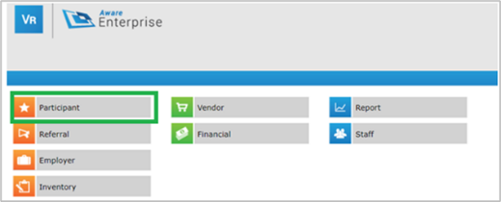
2.02 Select The Layout Tab | - Select the Layout tab. The New Case Search page displays.  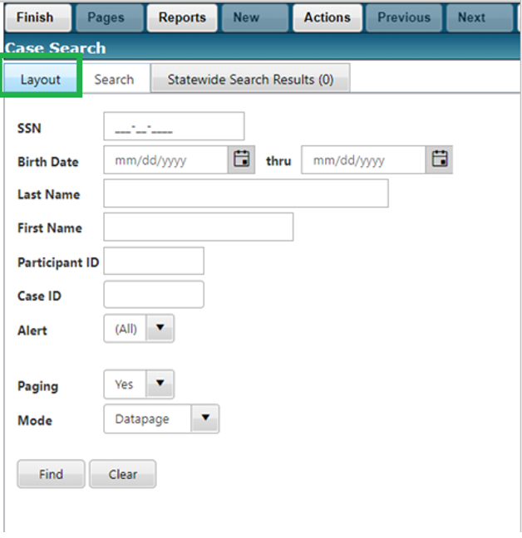
2.03 Change Selected Layout to Caseload - Open | - Use the Selected Layout drop down arrow to select “Caseload - Open” and select Apply.  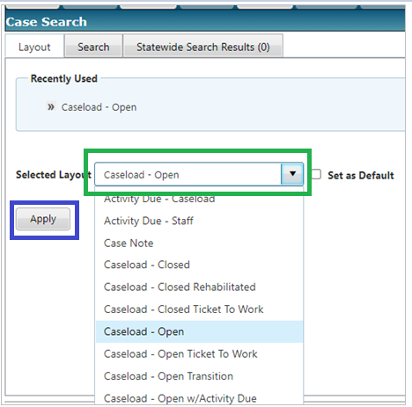
2.04 Select the Search Tab | - On the Case Search page, select the Search Tab.  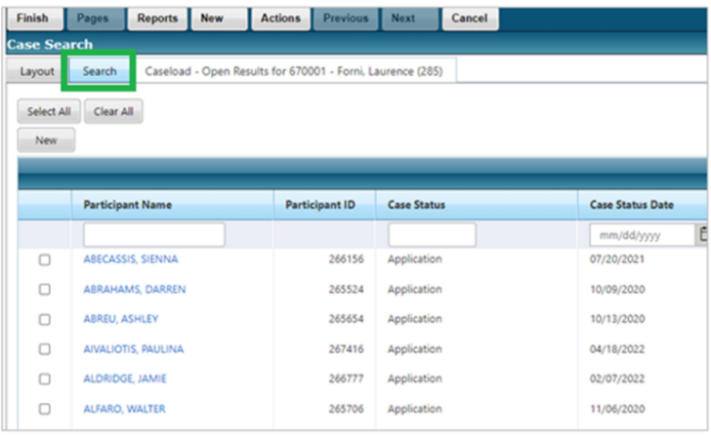
2.05 Clear Caseload (5 max) Field | - Once you have selected the Search tab, in the Caseload (5 max) field, use the ‘X’ token to clear the field.  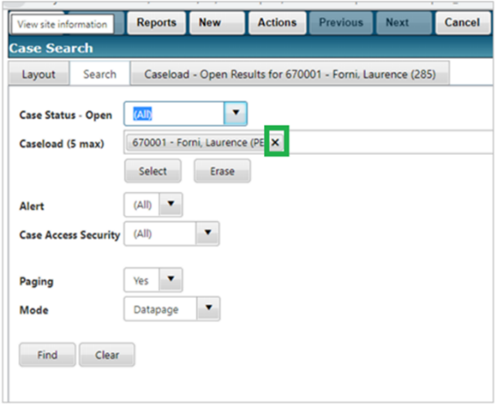  - Once the Caseload (5 max) field is empty, use the Select button to search for a list of Caseloads.  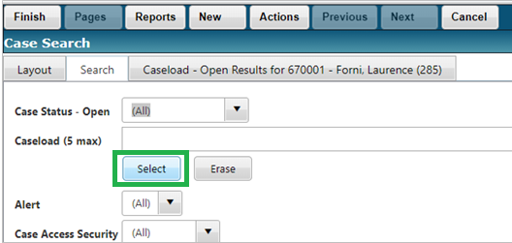
2.06 Search in Caseload Mini-Search Window | - The Caseload Mini-Search window will appear.  - In section 2: Results of Search, you can scroll to see a list of all available caseloads.  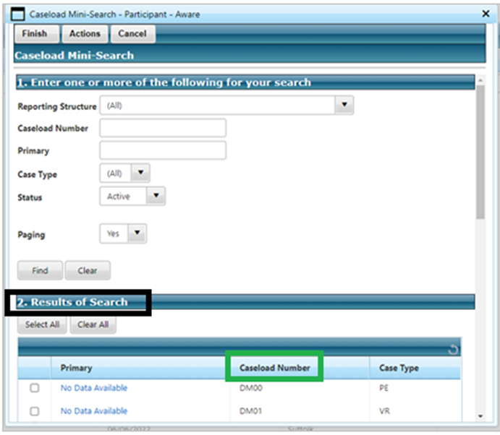
2.07 Filter Your Search | - You can also filter your search results to get more concise findings.  - In Section 1 on the Caseload Mini-Search window, in the Primary field, type in either your first name, or the first name of the staff member you would have caseload access for. Then select Find.  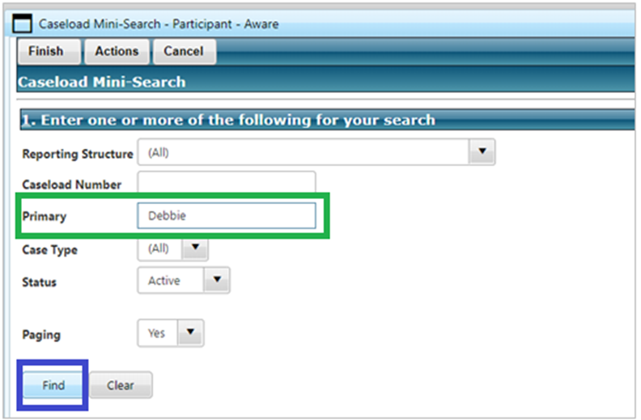
2.08 Search for Results | - In section 2: Results of Search, on the Caseload Mini-Search window, write down the Caseload number for the corresponding caseload. This will be the number you use when entering caseloads or setting your preferences.  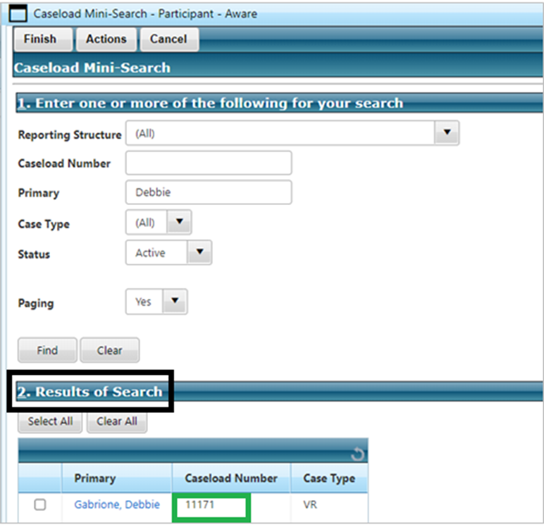  - NOTE: You do not need to select the caseload at this time, rather write it down and remember it for the next step.  - Select Cancel until you are back to the Aware Landing Page.  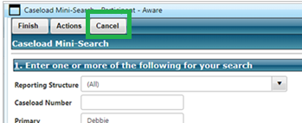
Objective 3: Update Preferences
3.01 Open Preferences Page | - From the Aware Landing Page, select the Preferences button.  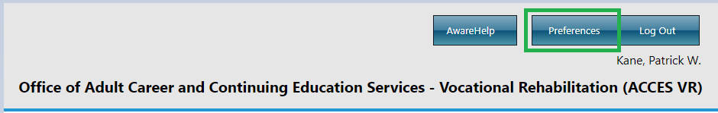
3.02 Enter Case Search Default Caseload | - In the Participant section, in the “Case Search Default Caseload” field, enter in the caseload number that you looked up in step 2.08.  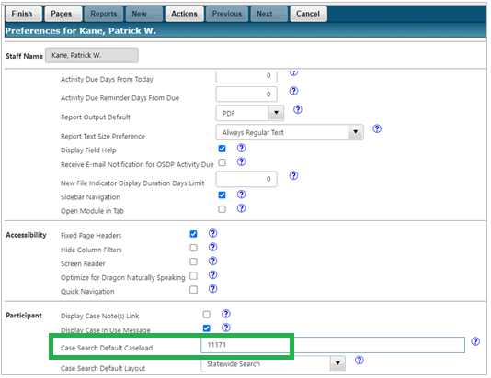  - Select Finish to save your changes.
3.03 Verify Changes | - Open the Participant module. The Case Search page displays.  - Select the Layout tab. The New Case Search page displays.  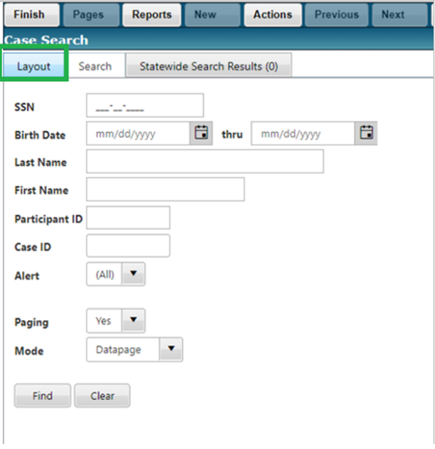  - Use the Selected Layout drop down arrow to select “Caseload - Open” and select Apply.  - Once you select Apply, you will see the new default caseload search appear.  