Testing Procedures
for AWARE
Eligible - Case Status and Auto Generated Letter

To the Tester: The step-by-step instructions below are provided for you to complete the process of working your case from Application to Eligible status, you will complete the following objectives:

Note: You will need to adjust your Aware Preferences for the Auto Generated Letter to become available. See

Pre-Test: Update Preferences
1. Determine Eligibility
2. Resolve ToDos and Move to Case Status: Eligible
3. Capture Case Notes
4. Manage Activity Due Reminders

Activity Name | Testing Procedure Notes
Pre-Test Step: Update Preferences to Allow for Auto Generated Letters
0.01 Select Preferences | - From the AWARE home page, select the Preferences tab.  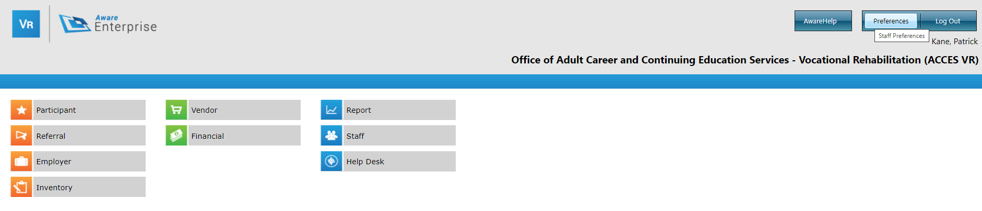  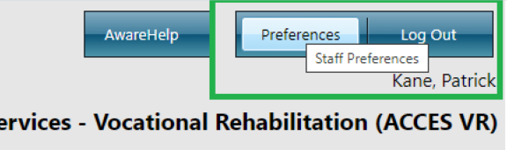
0.02 Check “Display Auto-Letter Generated Prompt” | - From your Preferences page, in Section 1: Staff Preferences, select the box for “Display Auto-Letter Generation Prompt”.  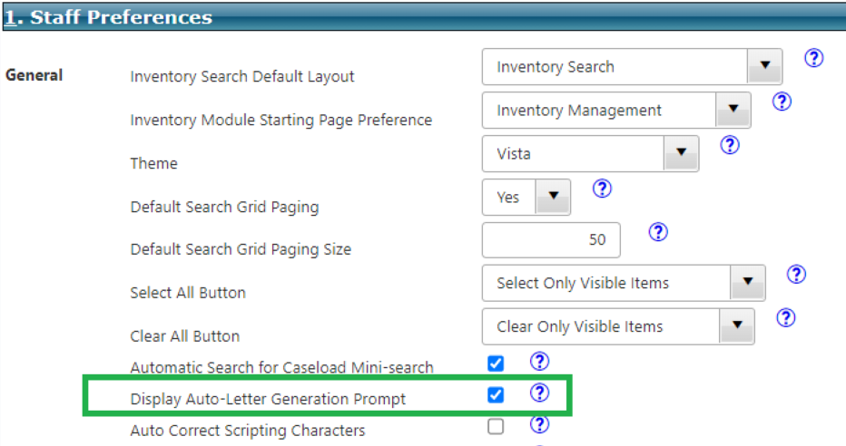  - Select Finish to save your changes.  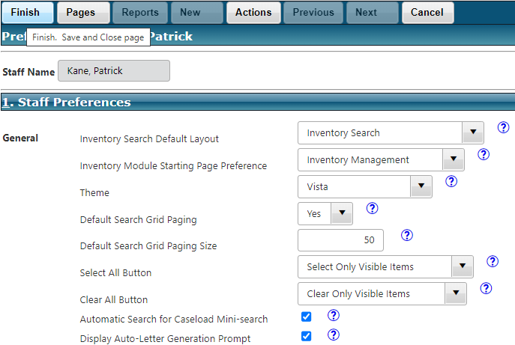
Objective 1: Determine Eligibility
1.01 Select Participant | - From the AWARE Home Screen Select the Participant Module.  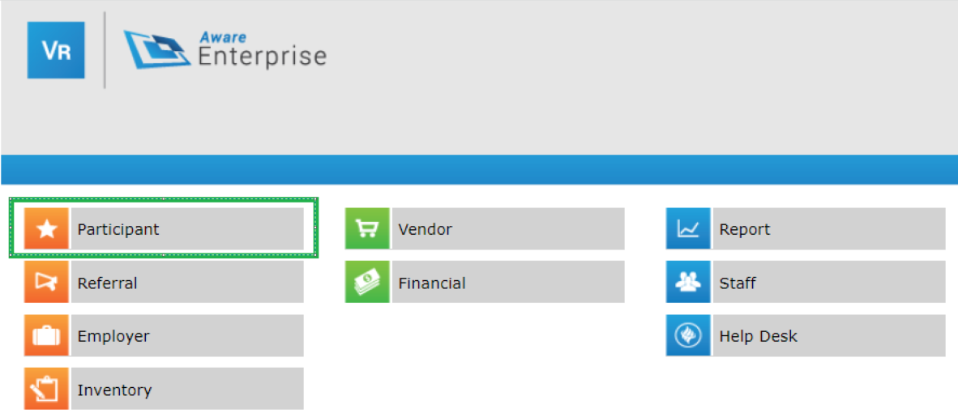  - Select an individual from your case search grid that you have completed all steps for Case Entry/Application. This individual will still be in case status: Application. Note that you can filter your caseload by typing in application in the provided parameter field under Case Status in the grid.  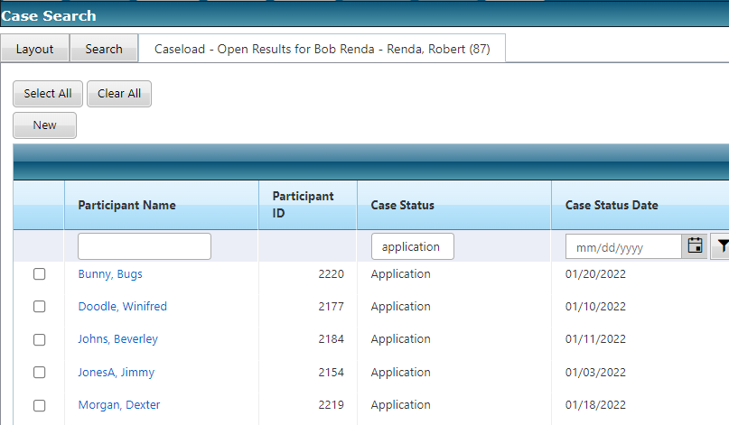
1.02 Display Participant Pages | - From the Case Management page, select the Pages link from the menu bar. The Participant Pages displays.  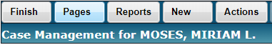  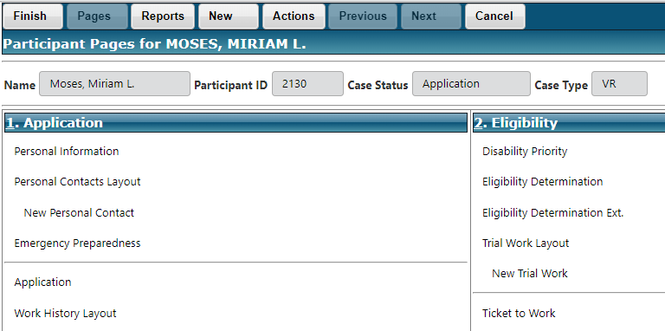
1.03 Display Eligibility Determination Page | - In Section 2: Eligibility on Participant Pages, select the Eligibility Determination link.  - The Eligibility Determination page displays.  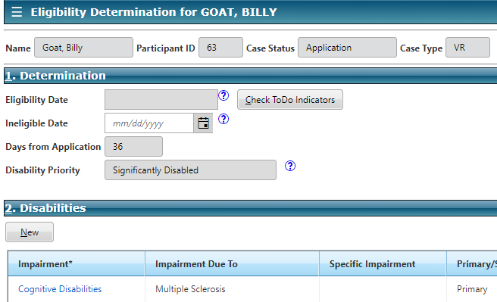  NOTE: Eligibility Date is read only at this point.
1.04 Impediments to Employment | - In Section 3: Impediment to Employment on the Eligibility Determination page, check at least one of the options for Impediments Options and enter text in the narrative box titled Other.
1.05 Documentation | - In Section 4: Documentation on the Eligibility Determination page, select at least one item from the Eligibility Rational Options and enter text into the narrative box titled Other for this section.  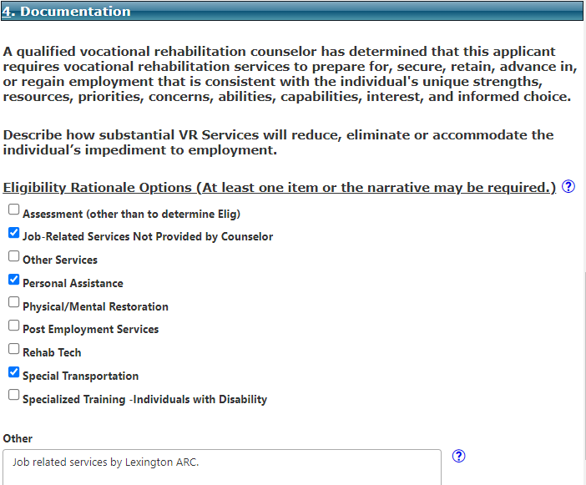
Objective 2: Resolve ToDos and Move to Eligible Case Status
2.01 Display ToDo Page | - Back at the top of the Eligibility Determination page, in Section 1: Determination, select the Check ToDo Indicators button.  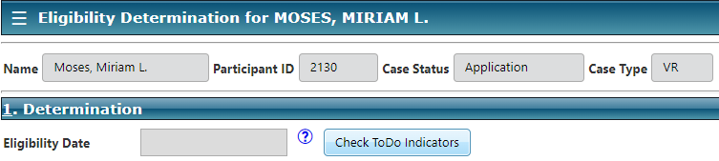  - The ToDo page Displays. NOTE: The following image is an example of which ToDos may be listed – depending on what you completed or have forgotten.  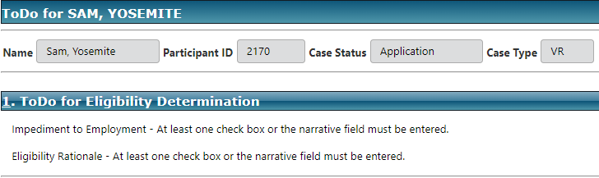
2.02 Select First ToDo | - On the ToDo page, select the first ToDo and fill in the required (**) information. This should be an Impediment to Employment ToDo.  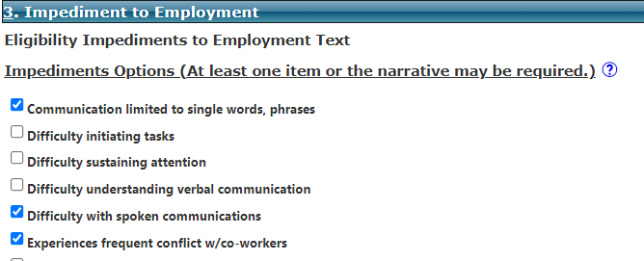  - On the main menu select Finish to return to the ToDo page (if you have any more ToDo.)
2.03 Complete Additional ToDo’s If Needed | - On the ToDo page, complete the remaining ToDos for your individual and select Finish to save any changes. After all ToDos are complete and you have saved your changes, you should see one more ToDo for Eligibility Determination appear – Eligibility Date is required.
2.04 Enter Eligibility Date and Select OK | - Select the Eligibility Date is required. (Personal Security Required) ToDo. Aware displays the Eligibility Determination page with the cursor on the newly editable Eligibility Date field. 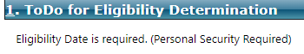  - Enter today’s date and select Finish on the main menu bar to save all changes on the page. You will see an alert box asking you to confirm.  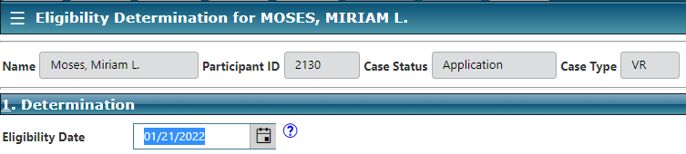  - Select the OK button to move case to Eligible status.  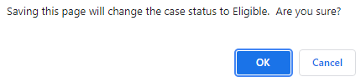
2.05 Launch Auto-Letter Generated Template | - An additional alert box will display asking if you want to generate an Eligibility Letter. Select OK.  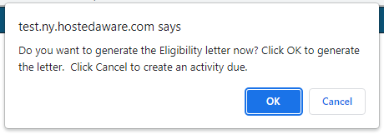  - This will launch the Auto-Letter Generation Template Selection mini-data page.  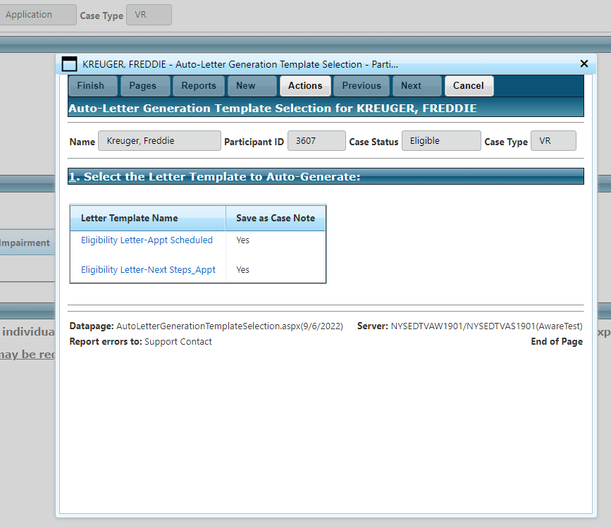
2.06 Select Auto Generated Letter | - In section 1: Select the Letter Template you wish to auto-generate.  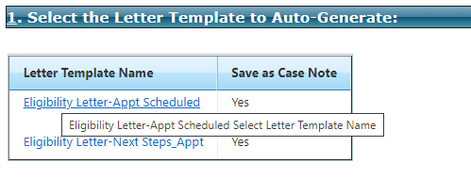  - This will launch the Letter Fill In data page.  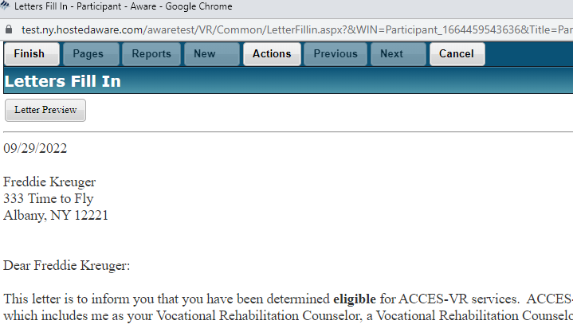  - Complete the fields in the Letter Fill In Preview.  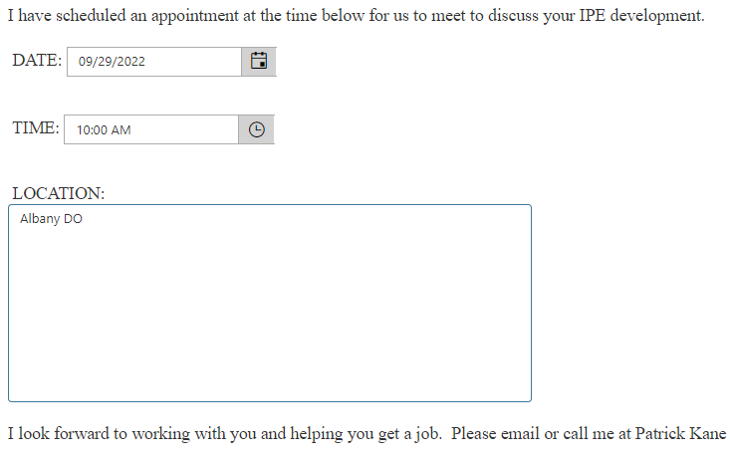  - At the top left of the Letters Fill In pop-up window select the Letter Preview button to generate a preview of your completed letter. At this point you can print or download the letter as needed.  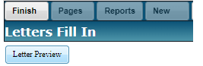  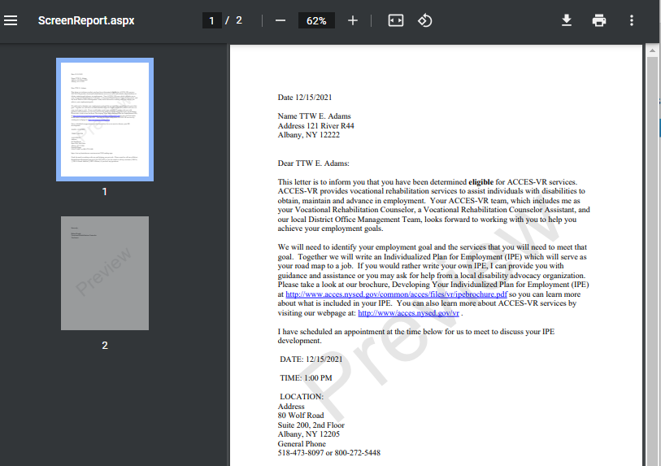
2.07 Finish to Save Letter | - First, close the Letter Preview by clicking the ‘X’.  - On the Letters Fill In window select Finish on the main menu to save your letter.  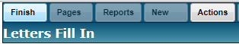  - This will generate another preview of this letter. This is the official preview of the letter that was saved. Why? Well let’s say when you previewed the letter in step 2.06 you saw a typo, corrected it, and saved your letter. This final preview is a final account of what was saved. You can print or download at this time if you like.  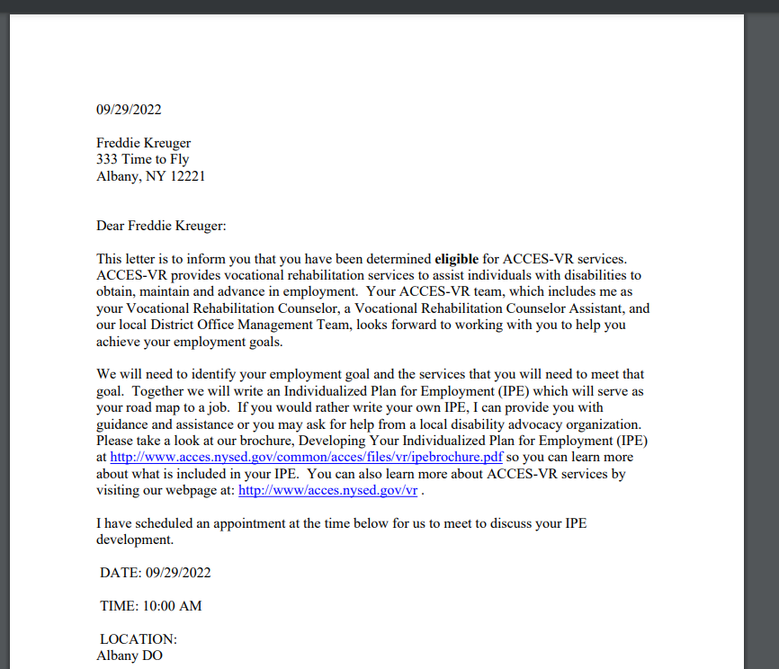  - Now, close the (finalized) Letter Preview by clicking the ‘X’. This will return you to the Case Management page for your participant.  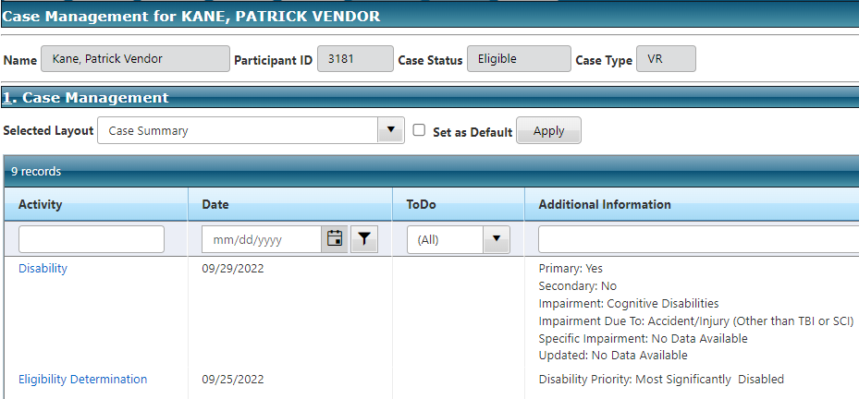
2.08 Verify Case Status Eligible | - From the Case Management page verify that the Case Status for your participant is now Eligible.  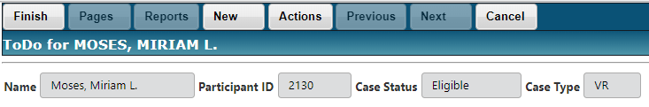
2.09 Verify Letter is in Case Notes | - From the Case Management page, use the Selected Layout drop-down to select Notes – All.  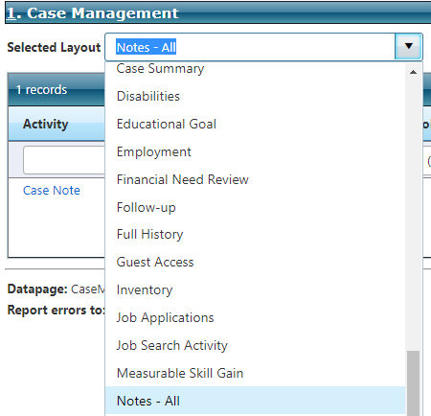  - Select Apply, and the Case Note records for your participant will appear.  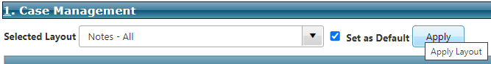  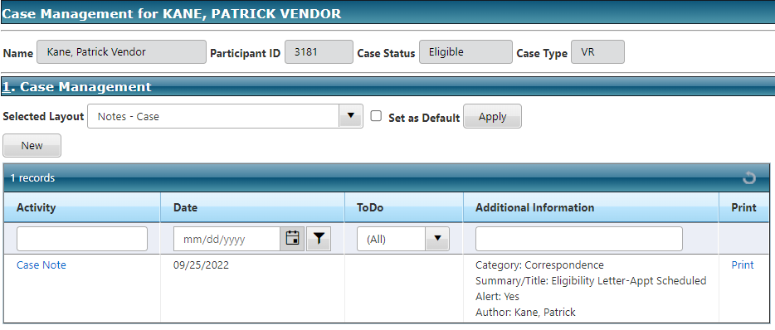  - Verify that the auto-generated letter is listed in your records table.  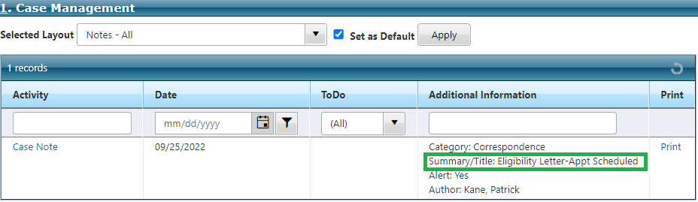
Objective 3: View and Create Case Note
3.01 Select Case Note | - Even though you have not directly created a Case Note yet, one was generated when you created the letter in Objective 3 above.  - Select the Case Note link in the records grid.  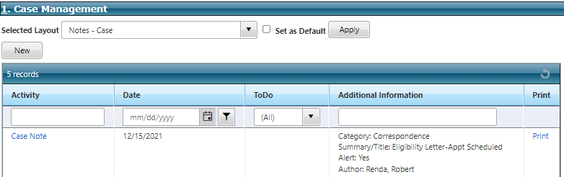
3.02 Verify Case Note Page Displays | - Verify that the Case Note page for participant displays  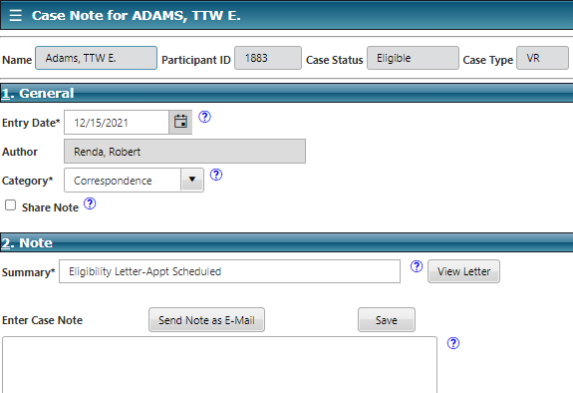  - Note: The number of days you will be able to edit/delete a case note is set to 10.  - At this point you could use the View Letter button in Section 2: Note to view, print or download your letter as needed.  - Select Cancel on the main menu to return to the Case Management page.  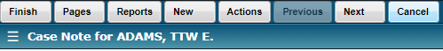
3.03 Select New Case Note | - From the Selected Layout Notes – Case on the Case Management page, select New above the records grid. This will display the Case Note page for participant.  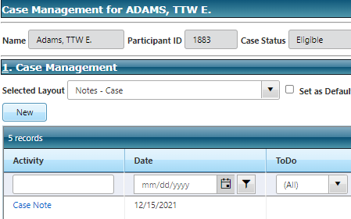  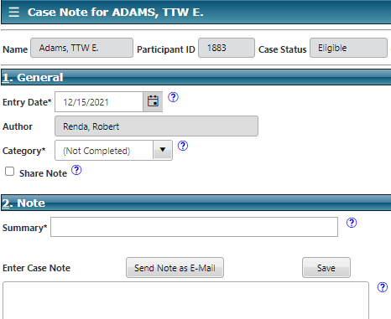
3.04 Select Category | - In Section 1: General on the Case Note page for participant, use the drop-down list to select a Category*.  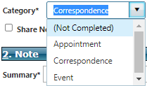
3.05 Enter Summary | - In Section 2: Note, enter text into the Summary* field.  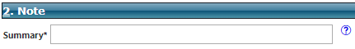
3.06 Enter Case Note Text | - In Section 2: Note, enter text into the Enter Case Note narrative field.  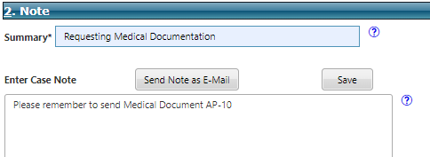  - Select the Finish link to save your case note and return to the Case Management page.
3.07 Verify Case Note In Records Grid | - On the Case Management page, verify that your Case Note is now recorded in the records grid.  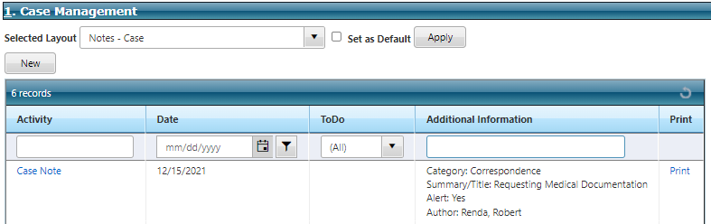
3.08 Display All Activities Report | - Select Actions from the menu bar and then select Print Reports for All Activities. You can use this report to view/print/download all activities including case notes.  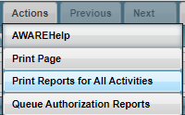  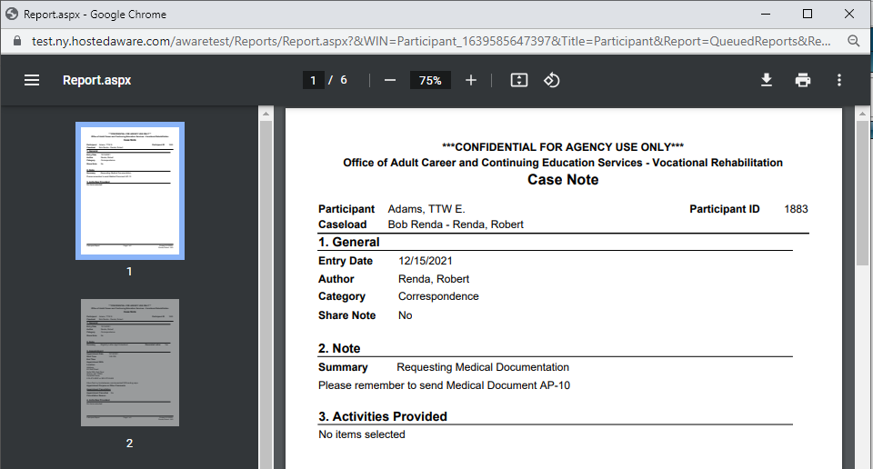  NOTE: Reports can also be generated from the Participant Reports page.
Objective 4: Create/Manage Activity Due Reminders
4.01 Display Activity Due - All Layout | - From the Case Management page, change your Selected Layout to Activity Due - All and select the Apply link.  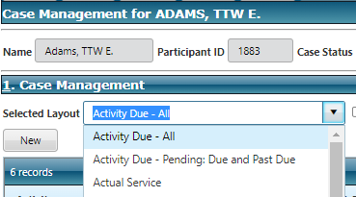
4.02 Create New Custom Activity Due Reminder | - Select the New link, above the grid. The Custom Activity Due page displays.  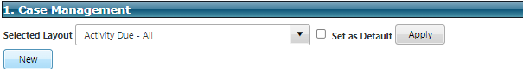  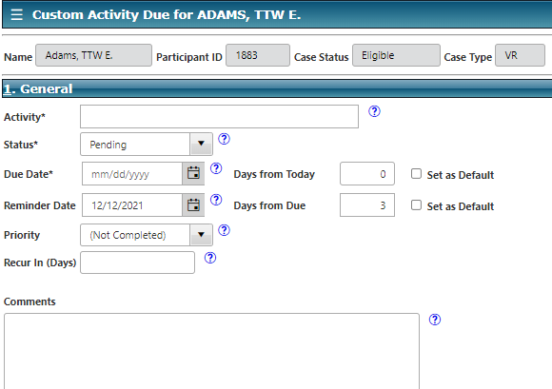
4.03 Activity Field | - In Section 1: General, enter text into the Activity* field.  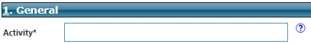
4.04 Activity Due Date | - In Section 1: General, enter a date in the Due Date* field.  - Alternately, you could enter a value in the Days from Today field, and this will calculate the Due Date for the activity.
4.05 Activity Reminder Date | - In Section 1: General, enter a date in the Reminder Date field.  - Alternately, you could enter a value in the Days from Due field, and this will calculate the Reminder Date.
4.06 Activity Comments | - In Section 1: General, enter text in the Comments field.  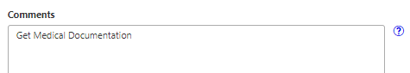
4.07 Finish To Save Custom Activity Due | - On the main menu of the Custom Activity Due for participant page, select Finish to save and return to the Case Management page.  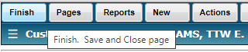
4.08 View Activity Due – All Layout | - Once you return to the Case Management page, change you layout to Activity Due – All if needed to view the Activity records grid. Your Custom Activity Due that you just created may be the only item or may be among several.  