How To:
Create an Activity Due for Supervisor to Complete “Ready for Review” on drafted Authorization.

When a supervisor is needed to review a drafted authorization to determine whether it is ready to be issued, the counselor can create an Activity Due that will direct the supervisor directly to the drafted authorization that needs their clearance.

To complete the process of creating an Activity Due for a supervisor, alerting them to review a drafted authorization, you will take the following path:

1. Counselor Selects Ready for Review
2. Counselor Creates Activity Due for Supervisor
3. Supervisor Checks Activity Due’s & Selects Ready for Issue
4. Supervisor Creates Activity Due for Counselor
5. Counselor Checks Activity Due’s & Issues Authorization

Activity Name | Notes
Objective 1: Counselor Selects Ready for Review
NOTE: In this example the Authorization has already been dratted and services have been selected.
1.01 Check box for “Ready for Review” | - On the Authorization data page, in Section 1: General, check the box for “Ready for Review”.  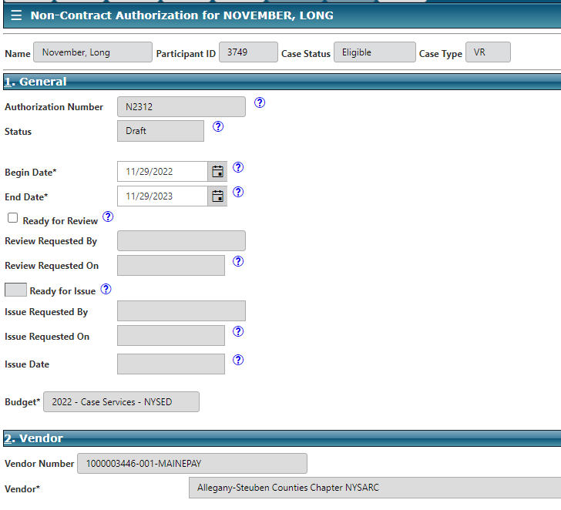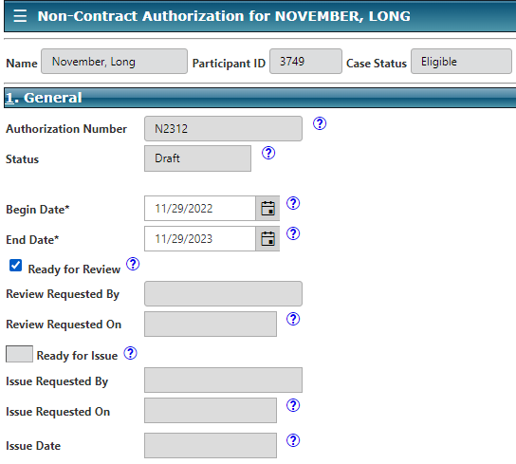  - Note: For this example, we are starting with an authorization that has already been drafted. This box should not be checked off unless the authorization has been drafted and services have been selected. To check to see if an authorization has services selected, scroll to Section 3: Items*, and make sure there is at least one item listed in the record table.  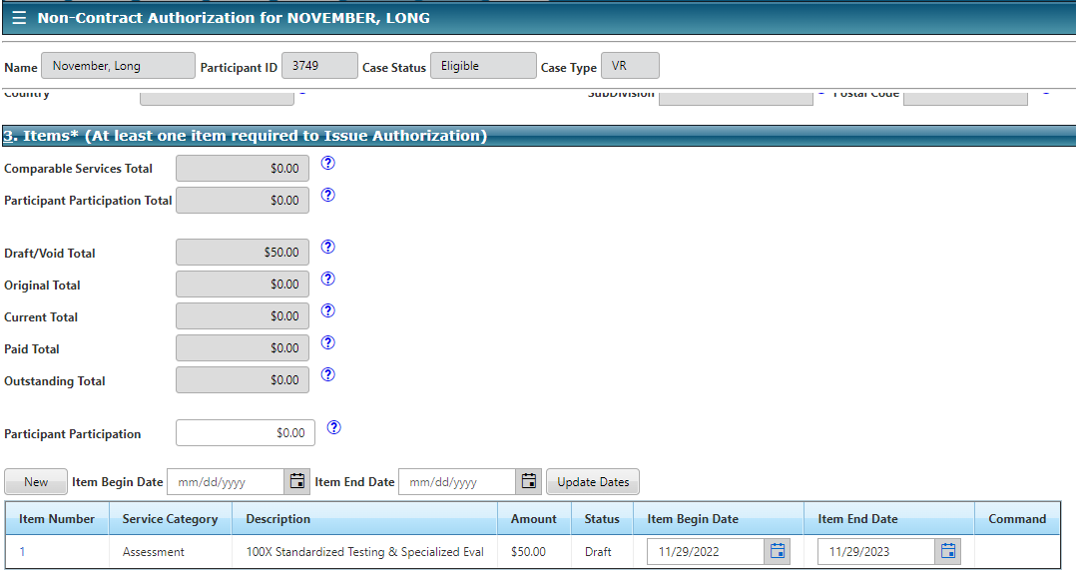
Objective 2: Counselor Creates Activity Due for Supervisor
2.01 Select Activity Due | - From the Main Menu on the Authorization data page, select New Activity Due.  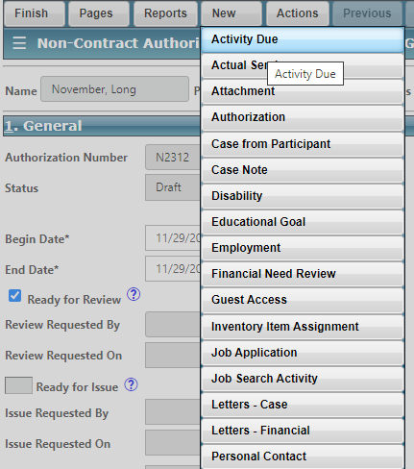  - An alert will pop up asking if you want the activity due to be related to the Authorization Data page. This will make it easier for the supervisor to complete the activity due. Select OK.  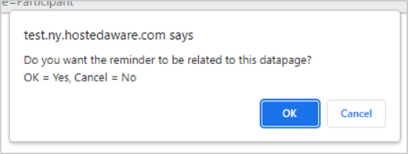
2.02 Complete General Information Fields | - The Custom Activity Due data page will appear. In Section 1: General, enter text into the Activity* field.  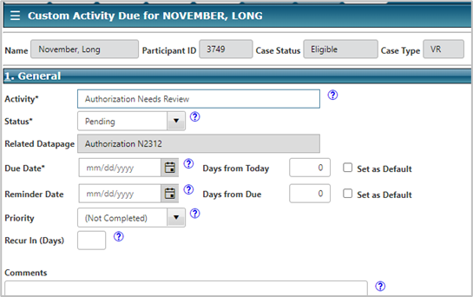  - Enter in a date in the Due Date* field.    - Use the dropdown arrow in the Priority field to select either High or Low.  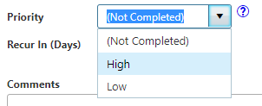  - NOTE: You can also leave an additional message in the Comments field.
2.03 Assign Activity Due | - In Section 2: Assign To, on the Custom Activity Due data page, select the New button.  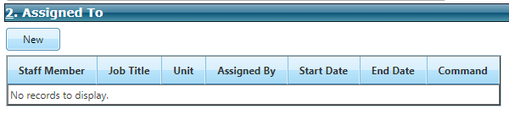  - The Activity Due Staff Assignment mini window appears.  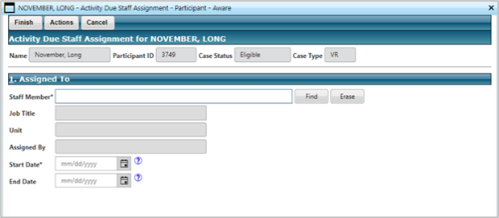  - You can type the name of the staff member you wish to assign the activity due to in the Staff Member* field. Aware will auto generate selections based on your entry.  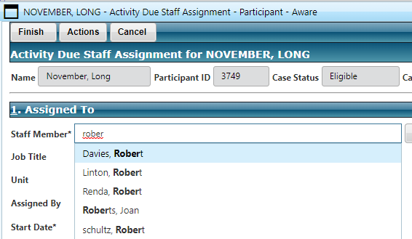  - You can also search for the staff member by selecting the Find button  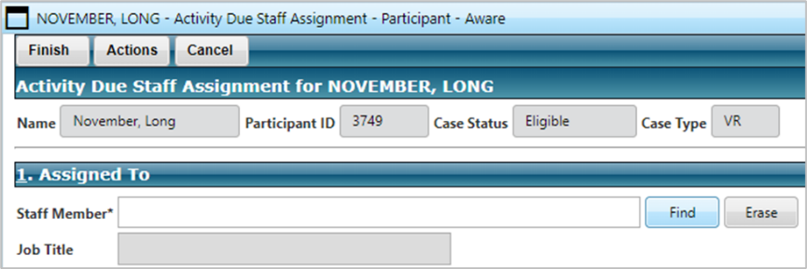  - This will launch the Staff Mini-Search window where you can search by name or unit to select the appropriate staff member. Once your search filters are set, use the Find button to see the results of your search.  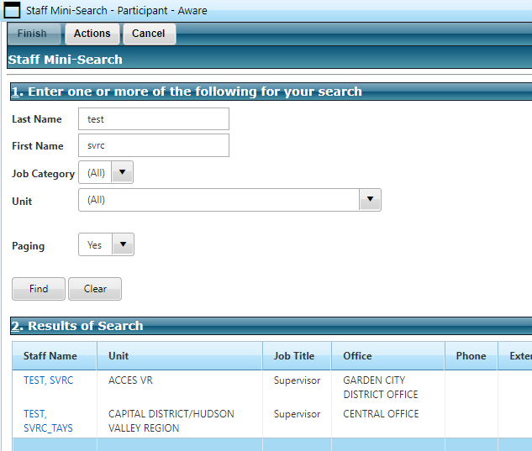  - Once you select the link of the staff member from Section 2: Results of Search, their name will auto populate the Staff Member* field back on the Activity Due Staff Assignment data page.  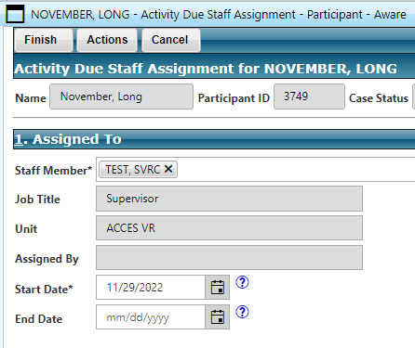  - Enter today’s date into the Start Date* field and select Finish from the Main Menu.  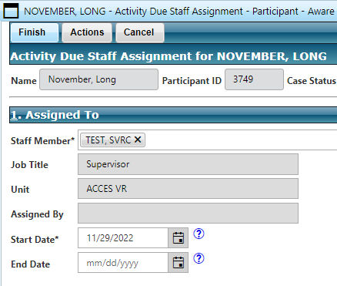
2.04 Complete Activity Due | - The Custom Activity Due data page should display. Make sure that the staff member you assigned the Activity Due to’s name is showing in Section 2: Assigned To. Then select the Finish button from the Main Menu.  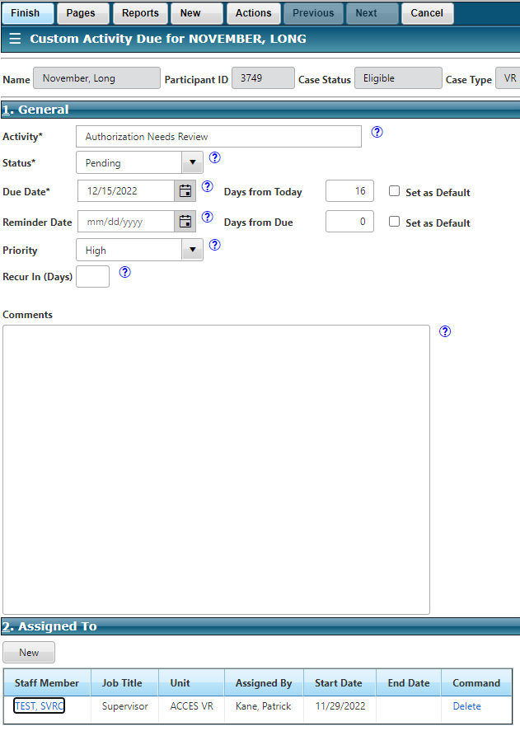  - The Authorization data page will display.  - Select Finish.  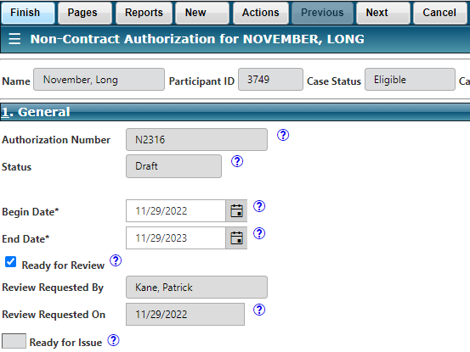  - The Case Management page for that participant will appear. Select Finish.  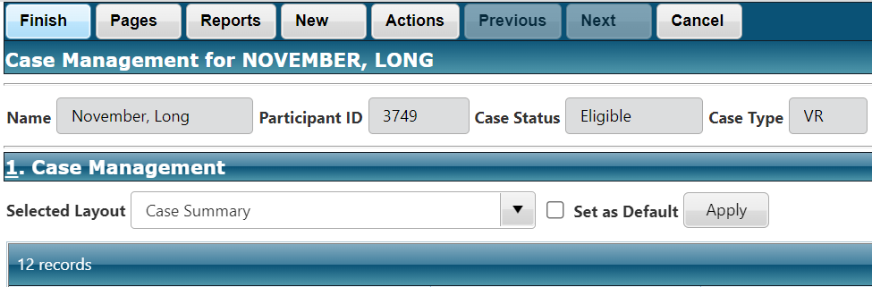
Objective 3: Supervisor Checks Activity Due’s & Selects Ready for Issue
NOTE: Objective 3 outlines the steps the Supervisor would take to complete the Activity Due
3.01 Select Participant Module | - As a supervisor, once logged into Aware and on the landing page, select the Participant Module.  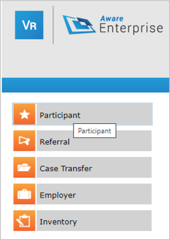  - From the Case Search page, under the layout tab, choose the Activity Due – Staff layout and select Apply.  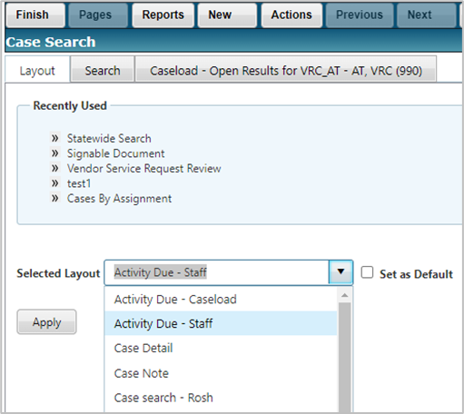
3.02 Filter Search Results | - From the Case Search page, select the Search tab.  - With the search tab selected, make sure that the Activity Status field has its drop-down set to “(All)”. *This is a very important step*  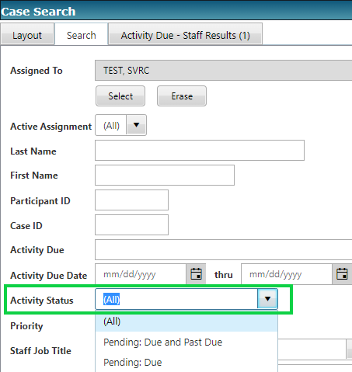  - Now make sure that the Related Datapage field has its drop-down set to “Authorization”.  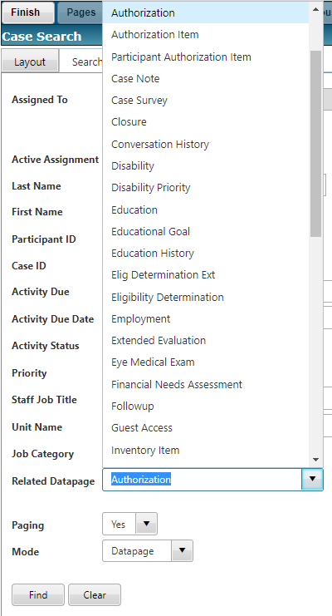  - Select Find.
3.03 Select Related Datapage | - The Search Results should display.  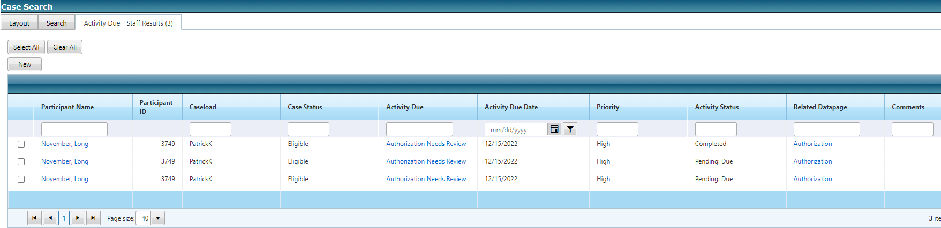  - There are several different columns which have links you can select.  - The Activity Due column provides you information about what the activity is requiring, “Authorization Needs Review” for example.  - The Activity Status column provides information on the status of the activity due, e.g., Completed, Due, Past due.  - The Related Datapage column will bring you directly to the data page that the activity due is asking you to complete.  - Select the Authorization link in the Related Datapage column, that does NOT have an activity status of completed.  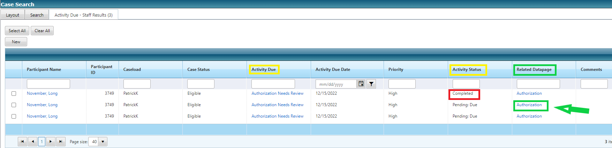  - This will take you to the Authorization page related to this activity due.  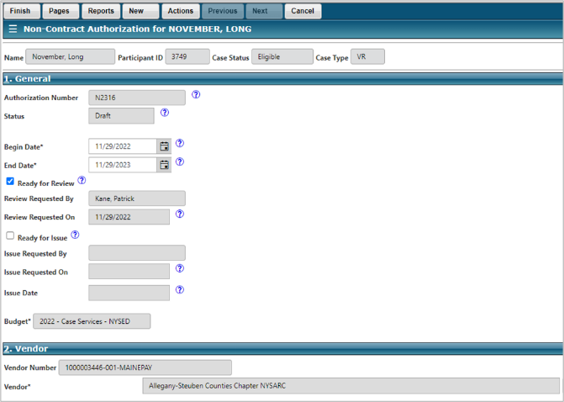
3.04 Select Ready for Issue | - From the Authorization page, the supervisor should see the “Ready for Review” box already checked off and the “Ready for Issue” box unchecked.  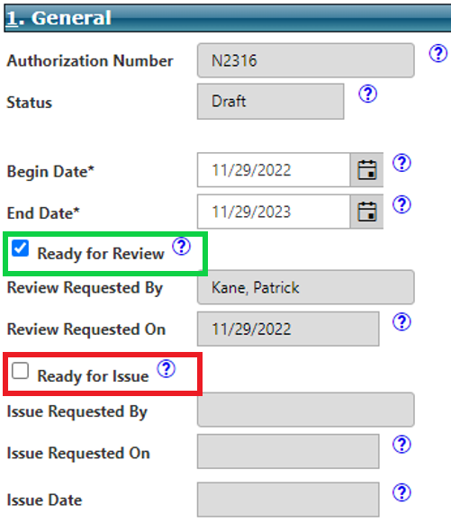  - The supervisor then looks over the authorization and checks the services selected in Section 3: Items.  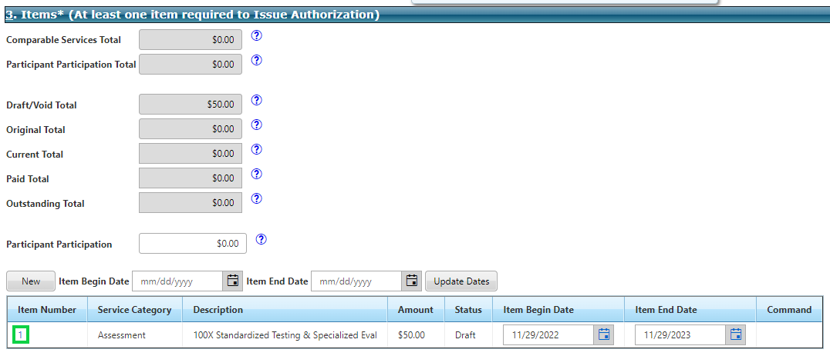  - Once the authorization has been checked, the supervisor can check off the box for, “Ready for Issue”.  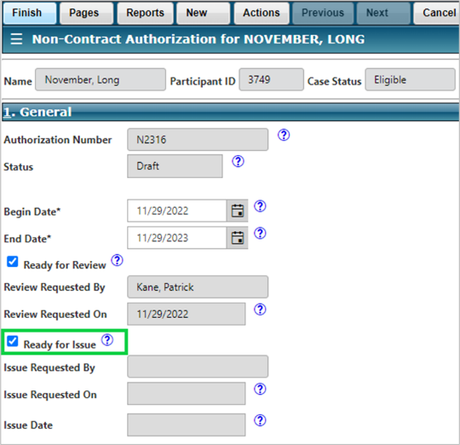  - At this point the Supervisor has a few options, depending on how their district office will handle the issuing of authorizations. They could either (1) Issue the authorization themselves or (2) create an Activity Due for the counselor to complete the issuance.  - The supervisor could go ahead and Issue this Authorization right from this point. To do so they would select Actions Issue Authorization.  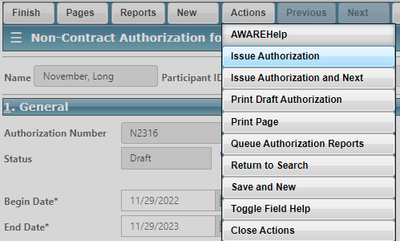  - The supervisor could also create an Activity Due for the counselor, alerting him/her to complete the process of issuing the authorization. See objective 4 below.
Objective 4: Supervisor Creates Activity Due for Counselor
NOTE: Objective 4 outlines the steps the Supervisor would take to create an activity due reminder for a counselor to complete the process of issuing an authorization.
4.01 Create Activity Due | - From the Authorization page, select New Activity Due  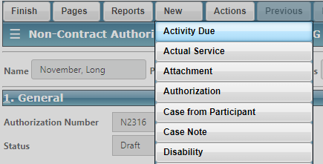  - An alert will pop up asking if you want the reminder to be related to the authorization data page, select OK.  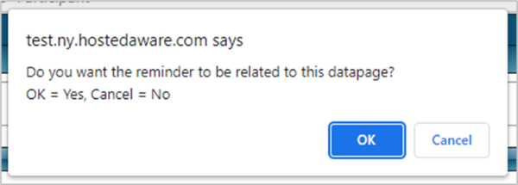  - The Custom Activity Due data page will display. Complete the following...  - Fill in information in the Activity* field,  - Enter a date for the Due Date*  - Set the Priority  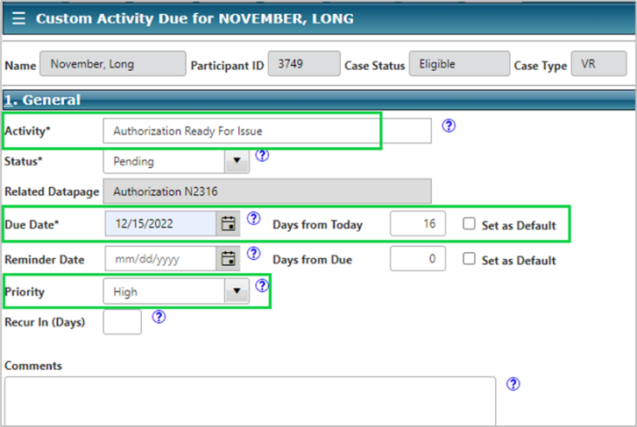
4.02 Assign Activity Due | - In Section 2: Assign To, on the Custom Activity Due data page, select the New button.  - The Activity Due Staff Assignment mini window appears.  - You can type the name of the staff member you wish to assign the activity due to in the Staff Member* field. Aware will auto generate selections based on your entry.  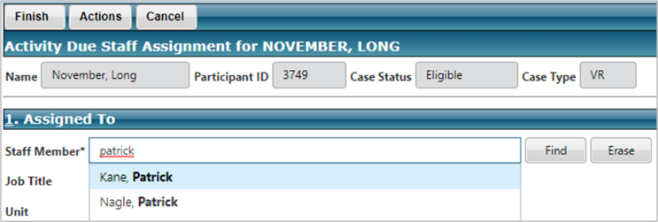  - You can also search for the staff member by selecting the Find button  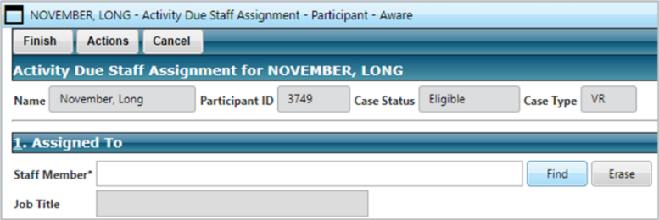  - This will launch the Staff Mini-Search window where you can search by name or unit to select the appropriate staff member. Once your search filters are set, use the Find button to see the results of your search.  - Once you select the staff member from the Results of Search, their name will auto populate the Staff Member* field back on the Activity Due Staff Assignment data page.  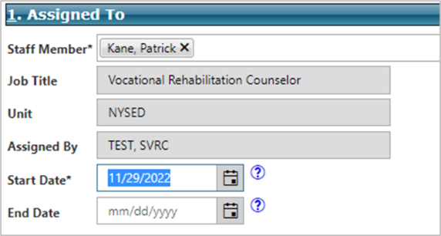  - Enter today’s date into the Start Date* field and select Finish from the Main Menu to save your selection.  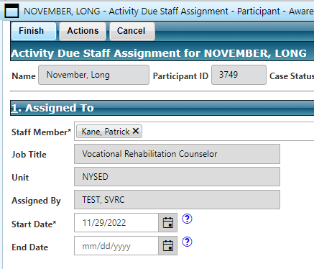  - The Custom Activity Due date page displays. Check to make sure there is a staff member listed in Section 2: Assigned To, and then select Finish to save and close the page.  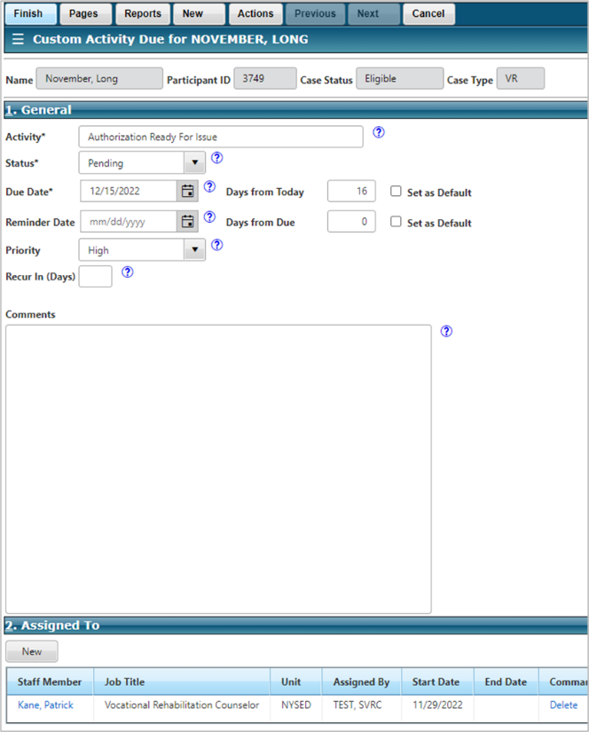  - The Authorization data page will display, make sure both “Ready for Review” and “Ready for Issue” are checked off. Then select Finish to close the page.  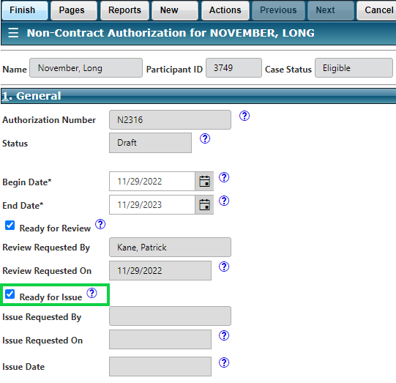
4.03 Complete Activity Due | - Once you finish out of the Authorization data page, you should see the search results that you originally looked up for your activity due’s. Now we need to mark them as Completed.  - From the search results, under the Activity Due column, select the link for the activity due you just completed.  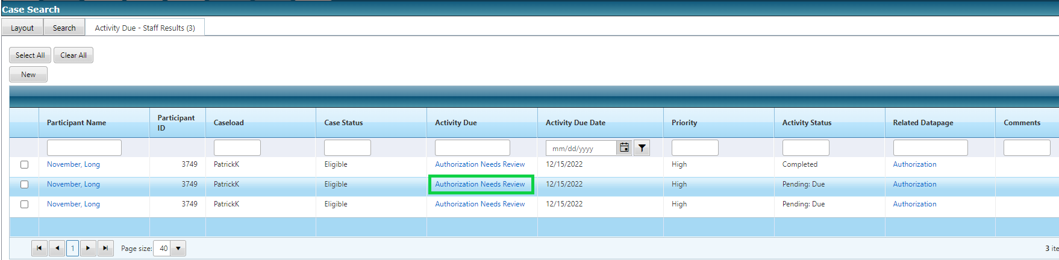  - The Custom Activity Due data page will display.  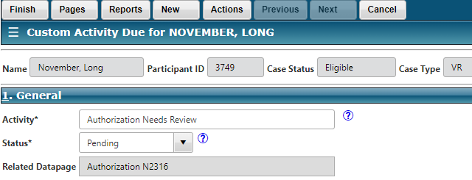  - In Section 1: General, use the drop-down arrow in the Status* field to select Completed.  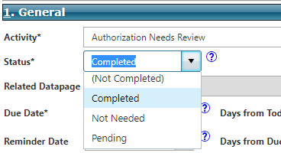  - Select Finish to save your changes.  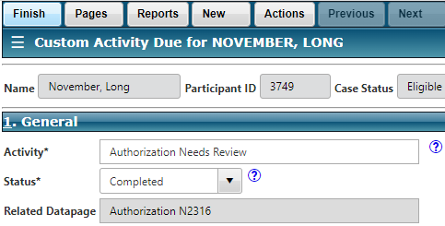  - The search results will again display, this time the Activity Status should say “Completed”.  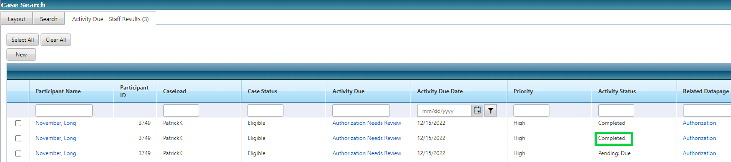  - Select Finish to return to the Aware landing page.  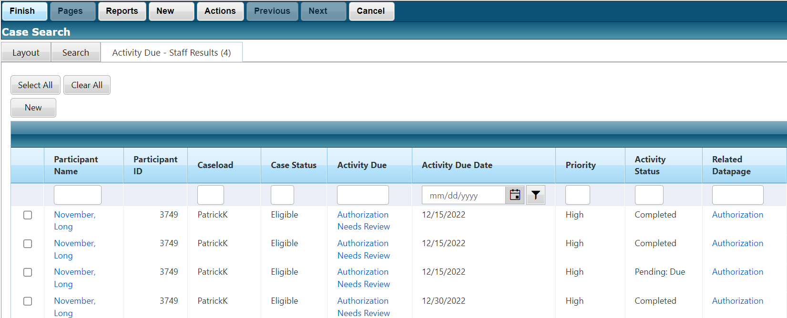
Objective 5: Counselor Checks Activity Due’s & Issues Authorization
NOTE: Objective 5 will outline the original counselor completing the final steps of issuing the authorization.
- To recap, at this point the counselor has drafted the authorization, assigned the activity due to their supervisor to review the authorization and deem it ready for issue. The Supervisor has gone in and reviewed the authorization via their activity due’s, checked off “ready for issue”, and then created an activity due for the counselor to issue the authorization.
- Now the counselor will compete the final steps.
5.01 Select the Participant Module | - From the Aware landing page, select the Participant Module.  - From the Case Search page, under the layout tab, choose the Activity Due – Staff layout and select Apply.
5.02 Filter your Search | - From the Case Search page, select the Search tab.  - With the search tab selected, make sure that the Activity Status field has its drop-down set to “(All)”.  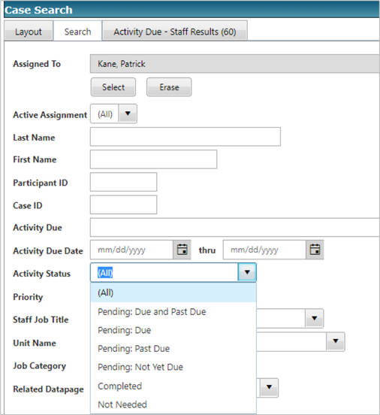  - Now make sure that the Related Datapage field has its drop-down set to “Authorization”.  Select Find.
5.03 Select Related Datapage | - The Search Results should display.  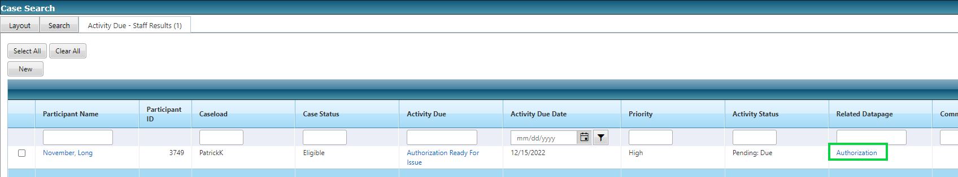  - There are several different columns which have links you can select.  - The Activity Due column provides you information about what the activity is requiring, “Authorization Ready for Issue” for example.  - The Activity Status column provides information on the status of the activity due, e.g., Completed, Pending: Due, Past due.  - The Related Datapage column will bring you directly to the data page that the activity due is asking you to complete.  - Select the Authorization link in the Related Datapage column, that does NOT have an activity status of “completed”.  - This will bring you to the Authorization page related to this activity due. 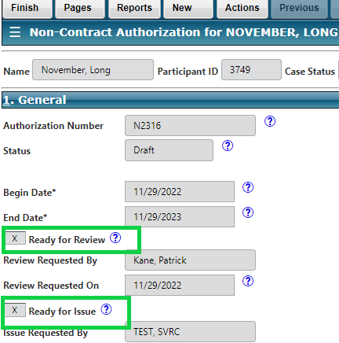
5.04 Issue Authorization | - On the Authorization page, check to make sure both the “Ready for Review” and “Ready for Issue” boxes are checked off.  - If both boxes are checked off than you can issue the authorization.  - From the Main Menu, select Actions Issue Authorization  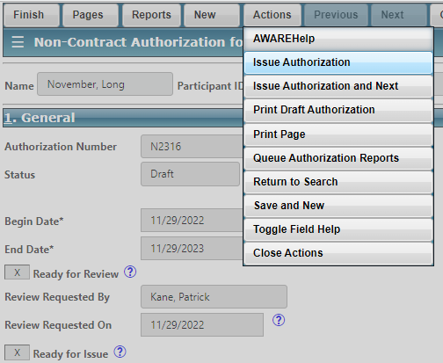  - An alert will pop up asking if you want to issue the authorization. Select OK.  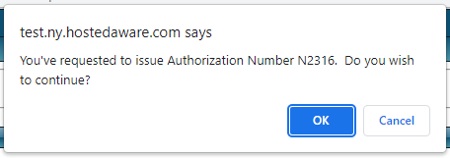  - A second alert will pop up telling you that the authorization has been issued. Select OK.  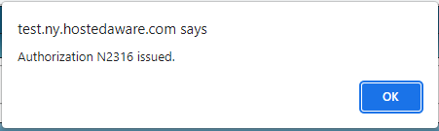  - Depending on your preferences, you may get a Report Prompt where you can review or print the authorization.  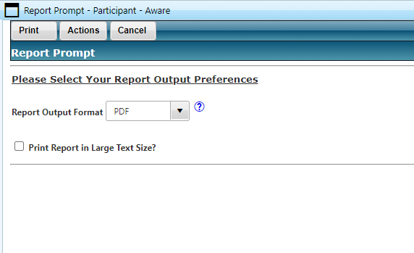  - Select Print or Cancel to return to the Authorization page. Select Finish to complete the authorization.  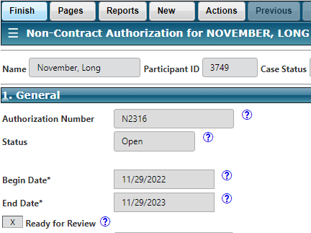
5.05 Complete Activity Due | - Once you finish out of the Authorization data page, you should see the search results that you originally looked up for your activity due’s. Now we need to mark them as completed.  - From the search results, under the Activity Due column, select the link for the activity due you just completed.  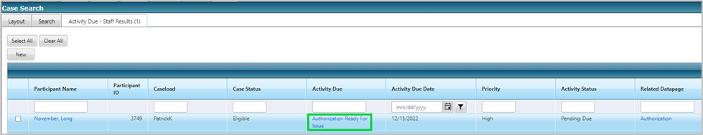  - The Custom Activity Due data page will display.  - In Section 1: General, use the drop-down arrow in the Status* field to select Completed.  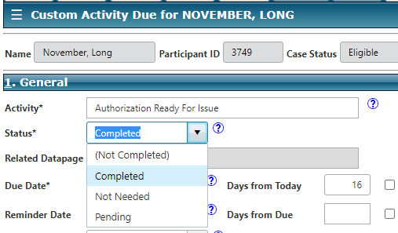  - Select Finish to save your changes.  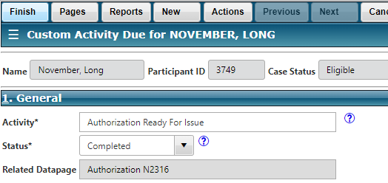  - The search results will again display, this time the Activity Status should say “Completed”.  