*How To:*

*Review and Approve Deliverables*

There are several ways in Aware for staff to **Review** **and** **Approve** **Deliverables**. **Primary Case Holders** will be able to review these deliverables by searching their **Activity Due – Staff** layout in the **Participant** **Module** as soon as the request from the vendor is submitted**. Additional Staff** that may need to review these deliverables can do so in the participant module AFTER the primary case holder has assigned them the Activity Due.

The step-by-step instructions below are provided to show the multiple ways primary case holders and non-primary case holders can review and approve deliverables.

***- The below graphic provides an overview of the different steps and the ensuing instructions for each path -***

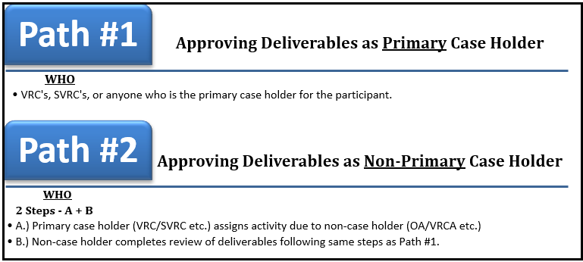

|  |  |
| --- | --- |
| **Path #1: Approving Deliverables as Primary Case Holder** | |
| **1.01 Select Participant Module** | * Once you have logged into ***AWARE***, select the **Participant** module. |
| **1.02 Change Selected Layout** | * From the **Case Search** page, select the **Layout** tab.      * Now change your **Selected Layout** to **Activity Due – Staff** and press **Apply**. |
| **1.03 Filter Search Results** | * Your search **Results** will display.      * Select the **Search** tab to display options to filter your search.      * Once the **Search** tab is selected, in the **Activity Due** field enter **Vendor Requested Payment**.      * Select **Find** to initiate your search. |
| **1.04 Select Vendor Requested Payment** | * Your search results will display. Select the **Vendor Requested Payment** link in the **Related Datapage** column.      * The **Vendor Requested Payment** data page will display. |
| **1.05 Verify Attachment** | * In **section 5:** **Attachments**, verify that there is an attachment in the records table.   *NOTE: This attachment would be where the vendor would attach the deliverables for the payment request. * |
| **1.06 Update Status** | * Once you have verified the payment request document, move up to **Section 3: Payment Request Review**, and use the drop-down arrow to change the **Status** field to **“Superior (Payment Allowed)”.** |
| **1.07 Finish to Save** | * At the top of the **Vendor Requested Payment** data page, select **Finish** to save your changes. |
| **1.08 Update Activity Due** | * The **Case Search** page reappears.      * Select the **New Vendor Requested Payment on Case** link in the **Activity Due** column. |
| **1.09 Change Status** | * The **Custom Activity Due** data page displays.      * In **Section 1: General**, select **Completed** from the drop-down list in the **Status** field.      * From the **Main Menu** select **Finish** to save your changes.      * Note: Now that you have changed the Status of the Activity Due and saved and closed that page, the reminder is no longer in the results grid. |

|  |  |
| --- | --- |
| **Path 2: Approving Deliverables as Primary Case Holder** | |
| If a VR Staff member wants to review the **Vendor Request for Payment** using the **Participant Module** for a case they have access to but are **not** the **Primary Case Holder** for (VRCA etc.), the primary case holder can assign the **Activity Due** to them. Once it is assigned, the VR Staff member will be able to see the activity due in their **Activity Due – Staff Layout** within the **Participant Module.**  **Step A.)** Primary case holder (VRC/SVRC etc.) assigns activity due to non-case holder (VRCA/OA etc.)  **Step B.)** Non-case holder completes review of requests following same steps as Path #1. | |
| **Step A** | |
| **2.01 Select Participant Module** | * Once you have logged into ***AWARE***, select the **Participant** module. |
| **2.02 Change Selected Layout** | * From the **Case Search** page, select the **Layout** tab.      * Now change your **Selected Layout** to **Activity Due – Staff** and press apply. |
| **2.03 Filter Search Results** | * Your search **Results** will display.      * Select the **Search** tab to display options to filter your search.      * Once the **Search** tab is selected, in the **Activity Due** field enter **Vendor Requested Payment**.      * Select **Find** to initiate your search. |
| **2.04 Update Activity Due** | * The **Case Search** page reappears.      * Select the **New Vendor Requested Payment on Case** link in the **Activity Due** column. |
| **2.05 Open Activity Due** | * The **Custom Activity Due** data page displays.      * In **Section 2:** **Assign To**, select the **New** button to assign this activity due to another staff member. * The **Activity Due Staff Assignment** mini window will appear. |
| **2.06 Assign Activity Due** | * In **Section 1:** **Assigned To**, begin to type the name of the staff member you want to assign the activity due to. Aware will auto generate as you begin to type. |
| **TIP** | * **Tip**: If you need to search for the staff member you can select the **Find** button to open up the **Staff** **Mini-Search** window.      * The **Staff Mini-Search** window will appear.      * Select **Finish** once you have selected the staff member you are searching for. |
| **2.07 Complete Assignment** | * Once you have selected the appropriate staff member, enter todays date into the **Start Date\*** field.      * Select **Finish** on the **Main Menu** to save your selection.      * The **Custom Activity Due** date page will display. Verify that the staff member now shows in the record grid in **Section 2:** **Assigned To.**      * Use the **Delete** link to remove the original assignee from the record table.      * An alert from Aware will pop up asking if you’re sure you want to delete the record, select **OK**.      * On the **Main Menu** for the **Custom Activity Due** data page, select **Finish** to save your changes. |
| **At this point, the non-case holder has been assigned the Activity Due and have completed Step A. From here, they would follow the same directions as Path #1 to review any Vendor Requests for Payment.** | |
| **Step B – Follow Path #1** | |