How To:
Vendor Requested Payments – Completing Payments on Approved Deliverables

NOTE: This is not a best practice guide for VR Staff. This is to document one way of accomplishing this task.

The Vendor Requested Payments are submitted from the Vendor Portal. From Aware, VRC’s and SVRC’s can review the deliverables and update the payment request status (Superior, Satisfactory, Needs improvement, etc.). Then the finance office for each district can complete the payment. To complete the payment approval process of an approved deliverable within AWARE, you will take the following path:

1. Search for Superior Payments
2. Complete Payment Page
3. Verify Total Outstanding = $0.00

Activity Name | Notes
Objective 1: Search for Superior Payments
1.01 Select Financial Module | - Once you have logged into AWARE, select the Financial module.  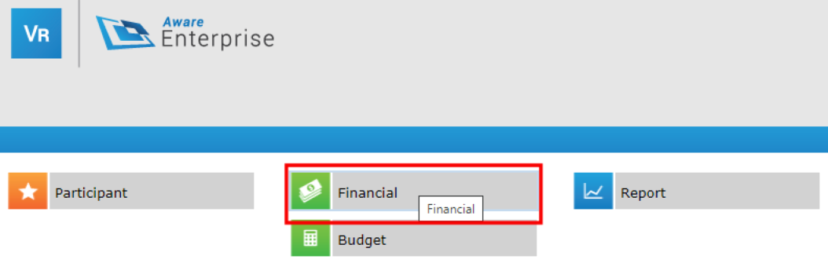
1.02 Change Layout | - Navigate to the Layout tab on the Financial Search page.  - Use the Selected Layout drop-down list to select and then Apply the Participant Details in Vendor Requested Payments layout.  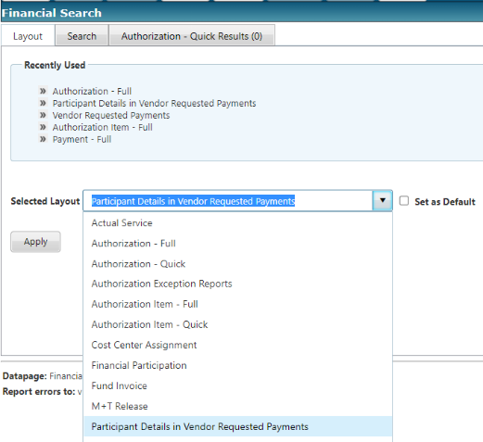
1.03 Filter Search Results | - On the Search page, in the Vendor Requested Payment Review Status field, use the drop-down arrow to select Superior (Payment Allowed).  - Note: You can select (all) to include all review status in your search.  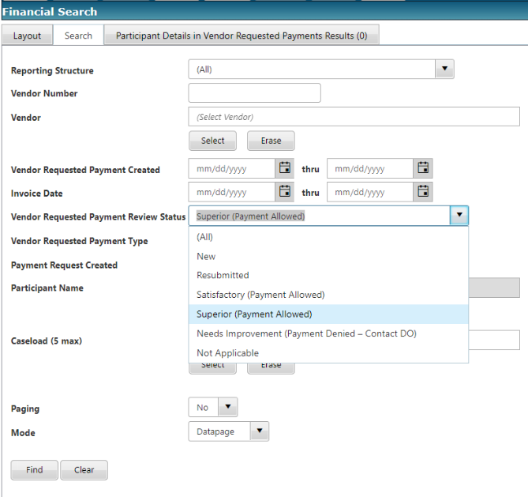
1.04 Filter Search Results | - On the Search page, in the Vendor Requested Payment Type field, use the drop-down arrow to select Invoice.  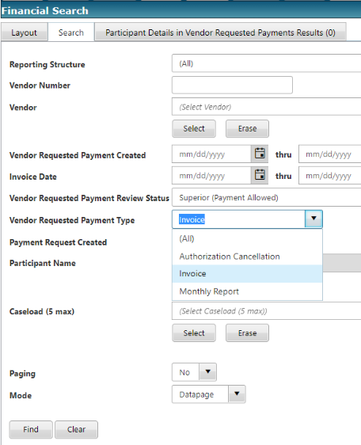  - On the Search page, in the Payment Request Created field, use the drop-down arrow to select No.  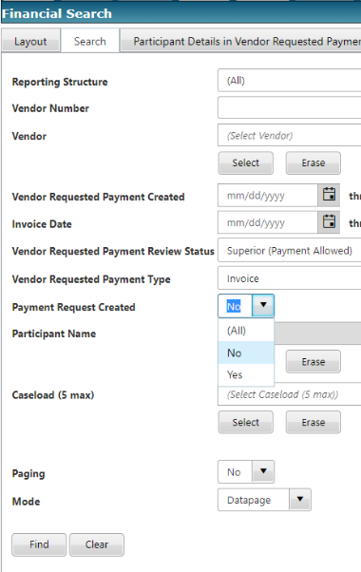  - Note: You can additionally filter your search results by Participant AND/OR Caseload.  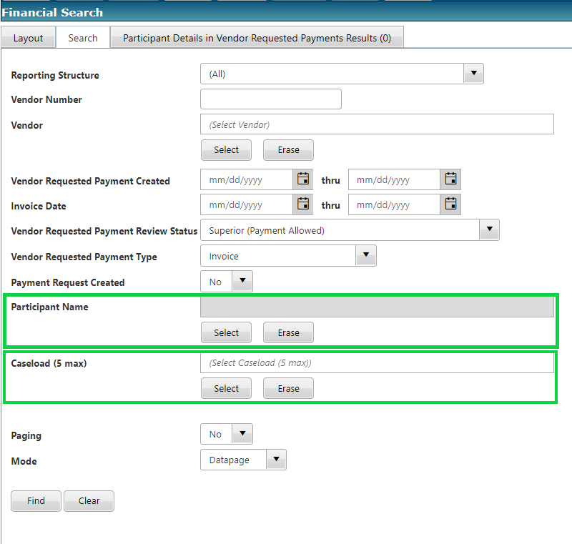
1.05 Filter Search Results | - Once your search filters are set, use the Find button to see the results of your search.  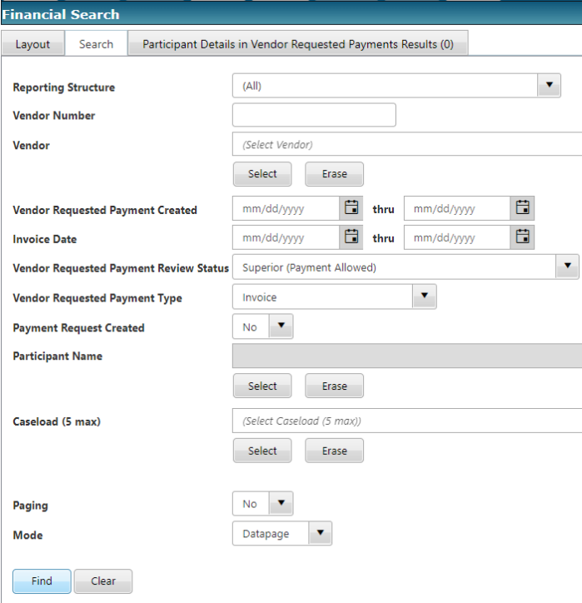
1.06 Select Payment Request | - Your search results will display.  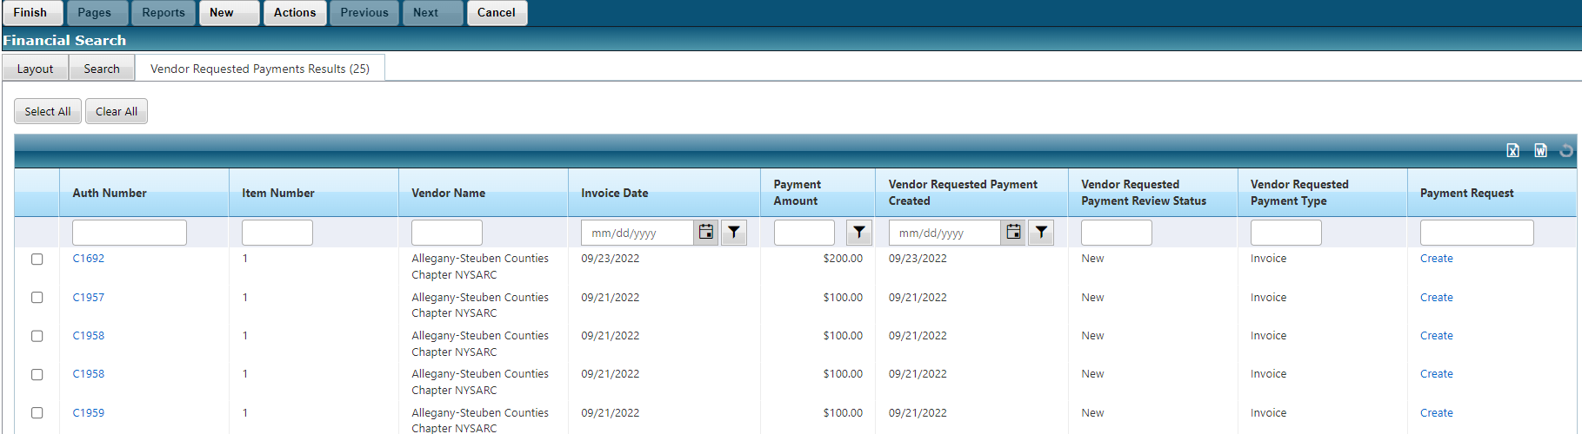  - Select the Create link for the payment in the Payment Request column.  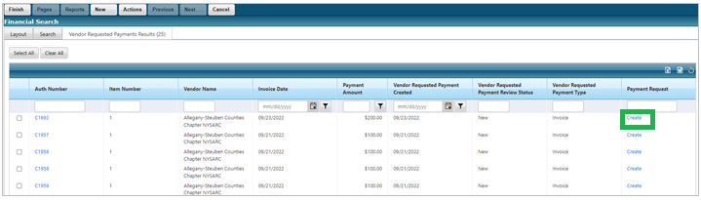
Objective 2: Complete Payment Page
2.01 Select Payment Action | - The Payment data page displays.  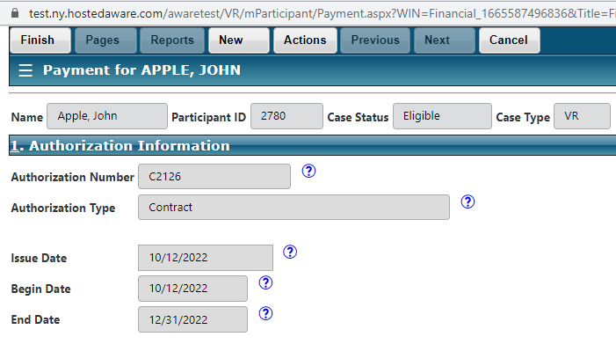  - On the Payment page, in section 2: Payment Information, select Final from the drop-down list.  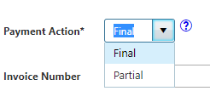
2.02 Enter Invoice Date | - On the Payment page, in section 2: Payment Information, enter a Date in the Invoice Date field.  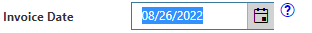  - TIP: Make sure that your Invoice Date is on or after your Service Start date.  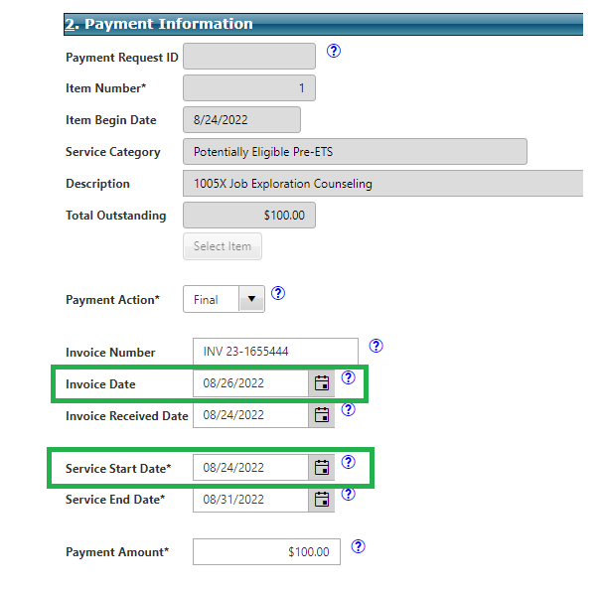
2.03 Enter Payment Amount | - On the Payment page, in section 2: Payment Information, enter an amount in the Payment Amount field.  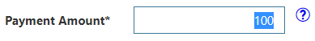  - TIP: Make sure your Payment Amount matches your Total Outstanding amount.  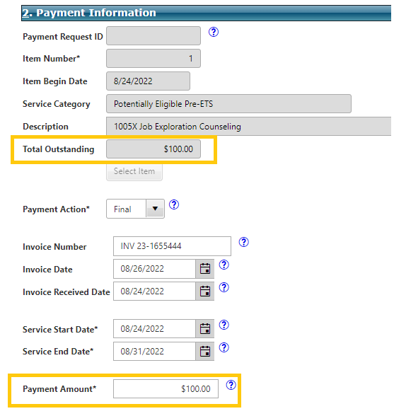
2.03 Check Attachments | - On the Payment page, in section 6: Attachments, you can see a history of all the attached files associated with the request.  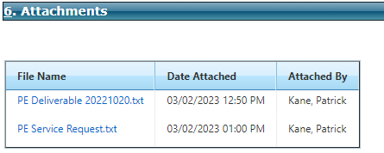
2.04 Check Ready for Release | - On the Payment page, back in section 2: Payment Information, check the box for, “Ready For Release”.  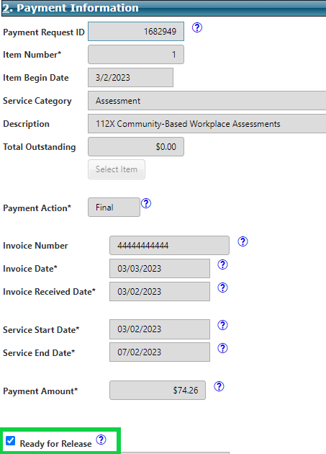
Objective 3: Finish Payment & Verify Total Outstanding is Now $0.00
3.01 Finish to Save | - From the Main Menu of the Payment datapage, select Finish to save and close the page.  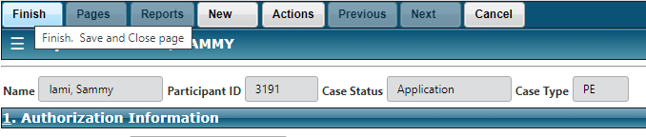
3.02 Verify Total Outstanding | - You will be taken back to the original search results.  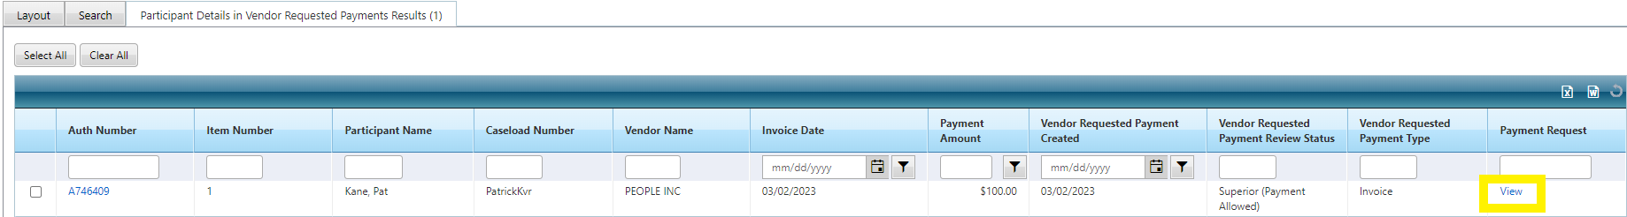  - Notice the Payment Request Column now displays as “View”. This changes from “Create” once the payment is created.  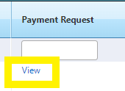  - Select the View link to go back into the Payment datapage.  - On the Payment page, in Section 2: Payment Information, verify that the Total Outstanding field is now $0.00.  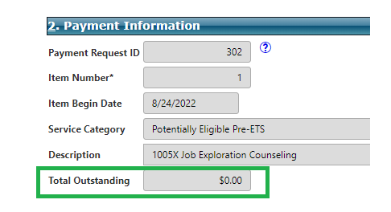
3.03 Finish | - From the Main Menu, select Finish to save and close the page.

