Creating a New Layout

How To: The step-by-step instructions below will show you how to create a New Layout. Completing the New Layout page is the first step of creating a new layout. It's used to select a layout as the basis for a new custom layout. The selection of a layout is optional. You can choose to create a new custom layout entirely from scratch. Layouts available are limited by personal security.

1. Access New Layout Page
2. Create New Layout
3. Select Search Criteria
4. Select Layout Options
5. View Your Layout

Activity Name | How To Procedure Notes
Objective 1: Access the New Layout Page
1.01 Display Manage Layouts Page | - From the AWARE main screen, select the Participant module.    - The Case Search page will display, select Actions from the main menu and then select Manage Layouts.  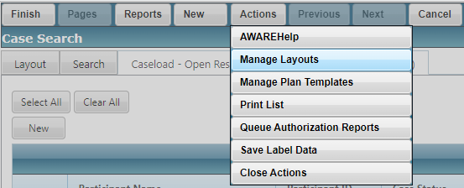  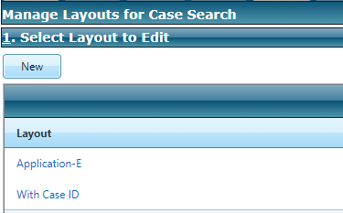
1.02 Display New Layout Page | - From the Manage Layouts page, select New to display the New Layout page.  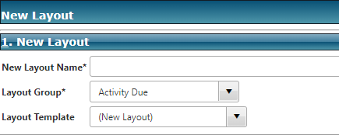
1.03 Enter New Layout Name | - Enter a name for the new layout. This appears on the Selected Layout lookup list in the Layout tab of the related Search page.  - For this How To exercise, enter the name of YourName-Details. Layout names need to be unique and if the name of a layout already exists in the system you will get an error and will need to choose another different name.  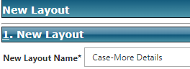
1.04 Select Layout Group | - Layout Group displays a list of groups applicable to the module the user is creating a layout for. This field is not displayed when there is only one layout group available for the module.  - A Layout Group allows for the display of different levels of information in a search page’s search results grid. Whether layout groups are used by a module, and the number of groups that are used by a module, varies. For example, Financial Search uses four layout groups: Authorization, Authorization Item, Payment, and Warrant.  - Choose Case for this How To exercise and we will create a Case-More Details layout.  NOTE: DO NOT CHOOSE Activity Due as a layout Group. It has too much redundancy because of the nature of many Activity Dues in a case.  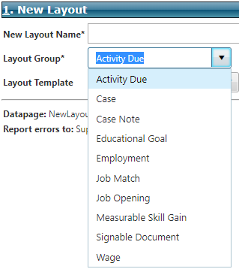
1.05 Select Layout Template | - Select from the lookup list if you wish to base the new template on an existing template. For this How To exercise, let us base our New Layout on the Caseload-Open template.  - Everything should look like this so far:  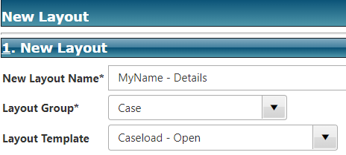
1.06 Select Finish For Layout Options | - Select Finish from the main menu to bring you to the Layout Options for your new layout.  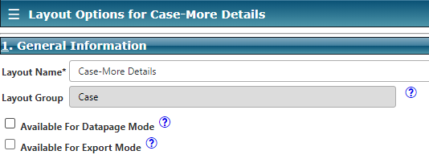
Objective 2: Selecting Layout Options
The Layout Options page is used to configure a custom layout. You are presented with a series of options that allow you to define the following characteristics of the layout:
- Search criteria that will be available to the user,
- Filters that will be automatically applied to search results,
- Data columns that will be displayed in the search results grid, and
- Groupings that will be used for the Case Search Listing Report.
2.01 Indicate Available Modes | - In Section 1: General Information on the Layout Options page, select the checkbox to indicate Available For Datapage Mode.  - In Section 1: General Information on the Layout Options page, select the checkbox to indicate Available For Export Mode. This will allow you the export your layout results to Excel or Word.  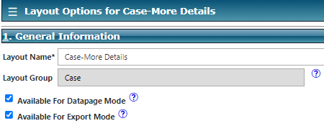
2.02 Select Search Criteria 1 - 4 | - This section sets which search criteria will be available to users. The selected fields appear on the Search tab of the related Search page.  - In general, you can:  - Select the New button to add a new row to the grid.  - Select the Delete button to delete a row from the grid.  - For this How To exercise, let’s change the criteria in the Filter Description column for the first FOUR. Use the drop-down lists to select the following for the first FOUR criteria (1 – 4) Last Name, First Name, Participant ID, Case ID:  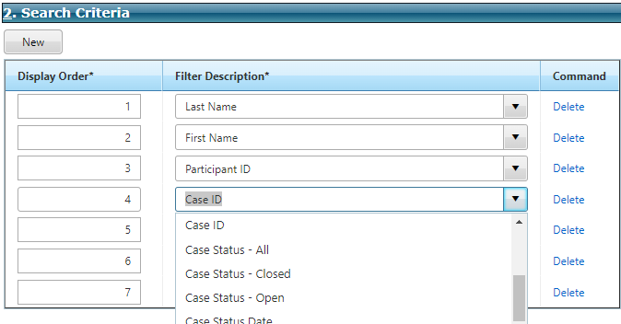
2.03 Delete Search Criteria 6 - 7 | - Delete the following criteria for 6 and 7.  - Make sure you leave Caseload (5 max) as a search criterion otherwise your layout will not populate with any results as you will have indicated that you do not want any caseload used.  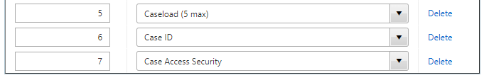  The Search Criteria grid should look like this:  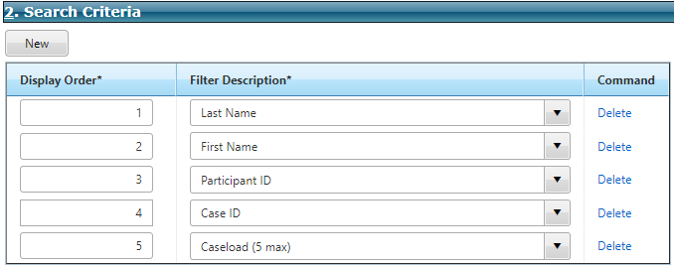
Objective 3: Setting Columns to Display
The system does not limit your ability to select the same field to display for more than one column and selecting fields that are not collected by your Agency. This limitation can result in creating a search results grid that displays redundant and/or non-existent information.
3.01 Select Column Description Values | - Use this section to set the columns that display in the search results grid on the Results tab of the Search page.  - In general, you can:  - Select the New button to add a new row to the grid.  - Select the Delete button to delete a row from the grid.  - Using the drop-down lists in the Column Description change the Columns to Display so that items 1 -5 contain the following (Participant Name, Participant ID, Application Date, Participant E-Mail Address, Participant Primary Phone):  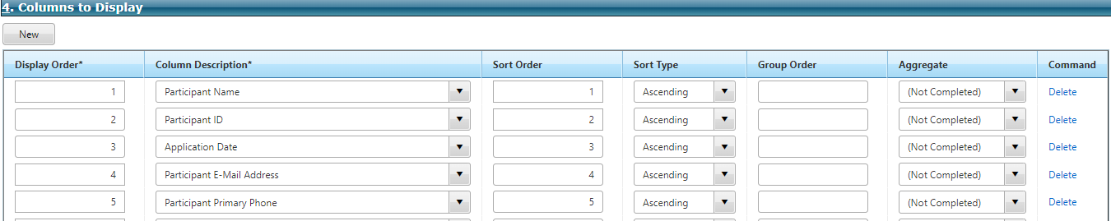
3.02 Delete Display Criteria | - Use the Delete link on the right side of the grid and delete any other items after Participant Phone Number.  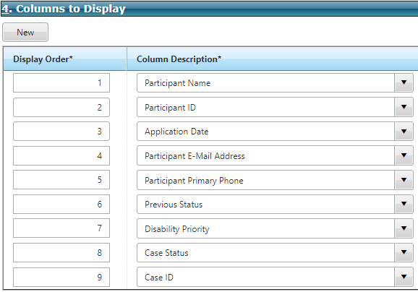  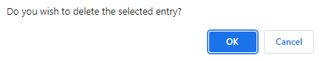  Ends up looking like this:  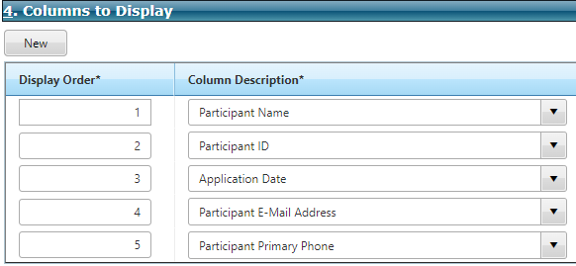
3.03 Finish To Save | - Select Finish from the main menu to save and close page.  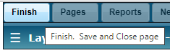
3.04 Finish To Exit Manage Layouts Page | - You will need to select Finish on the Manage Layouts page as well. Notice that your new layout is listed in the Layout grid. You can return to the Manage Layouts page and select that link to edit your layout.  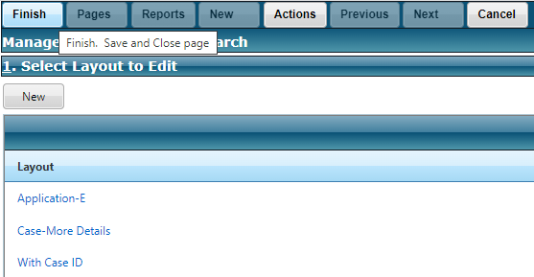
3.05 Use Your Layout | - Back on the Case Search page, select the Layout tab and change your Selected Layout to the Case-More Details one just created.  - Select Apply.  - Notice the highlighted in RED area below showing your export options.

